Bus stops - a component of urban improvement on the example of the city of Vladivostok

L A Chernyavina

Associate Professor of the Department of Design and Technogy, Insight of Sevis, Fashion and Design, Vladivostok State Economics and Services, Gogol's Wight 41, Vladivostok 640014, Russia

E-mail: suchan1963@mail.ru

Abstract. In this publication, the author examines on the problem of creating a comfortable urban environment on the example of the analysis and modernization of bus stops in Vladivostok. In the course of the research work, seven bus stops of the city were selected and analyzed in terms of their compliance with the General technical requirements adopted and put into effect by the order of the Ministry of transport of the Russian Federation, as well as in terms of convenience of their operation by citizens, for which appropriate surveys and sociological measurements were conducted. Also existing in the city bus stop compared with the best foreign and Russian counterparts. As a result of the research work, system errors were found: gross violations of GOST, defects in the design of structural elements, formal compliance with many requirements, on the basis of which a set of measures was developed and constructive solutions were proposed to significantly improve the network of bus stops of the city. The final project solution will be submit to the city administration.
Keywords: bus stop, metropolis, installation, visual comfort, marking, stop station, sidewalk, entrance.

1. Introduction
In the twenty-first century, human civilization remains predominantly urban, and today's metropolises are centres of both culture, science and art, and industry, and the outflow of people from the provinces is not decreasing or even increasing. Cities become huge agglomerations accumulating human flows and human activity, which directly affects both the ecology of space and the ecology of human relationships. Overcrowding, polluted air and water, social tension – this is the reality in which the inhabitants of big cities exist every day. Therefore, in the modern approach, urban design is not about buildings and structures, but about the attitude of users to them. French situationists led by the structuralist philosopher Guy Debord, who called the architecture of Le Corbusier prison and introduced a new term - psychogeography, which focuses not so much on Las Vegas as on fear and disgust in it, started talking about the dictatorship of the city and the need to center it back in the mid – twentieth century [1]. Through the efforts of Guy Debord, the urban environment today is perceived as an environment – a space that performs certain functions and causes certain emotions. Therefore, the designer should approach the projects not only as a designer, but also as a psychologist, and conduct what is called psychoanalysis of territories – whether the designed sites will be a place of total alienation or a point of attraction, whether visitors will want to stay longer or will try to leave this place. And Vladivostok in this sense presents huge opportunities for analysis, since the internal environment in it has long been formed spontaneously rather than systematically, outside the city's master plan, many infrastructure elements at best fulfill their direct purpose, outside of meeting such requirements as ensuring the comfort of citizens, and at worst – are unsuitable even for direct functionality. One of such painful points of Vladivostok is the objects of road and transport infrastructure, public transport stops. But in a developed industrial society, it is the comfort of road transport and social infrastructure that is the most important indicator of the quality of life.

2. Method
Analysis of the comfort of bus stops for citizens requires a comprehensive approach. In practice, the modernization of such areas and functional structures begins with a competent assessment of the existing material and technical base, as well as identifying areas that are in the most deplorable condition and require modernization in the first place. In this research the method of observation, analysis of the development of transport infrastructure in the historical paradigm, sociological survey, metadata collection, generalization were used. [2. Page 10].

3. Results
Conducted an excursion into history showed that with the advent and development of public transport in Russia at the end of the XIX century began to be designed and public stopping points [3. Page 2]. Moreover, the architects approached the design of these sites as meaning-forming elements of the urban landscape, they were thought out not only functional, but also aesthetic, and now are rightfully included in the architectural heritage of the era. (pic.1). The modern approach, as we can see, in this sense shows degradation rather than evolution: projected stops are not only visually ugly, stylistically inappropriate, but also do not perform their functions, and the comfort of users in terms of their emotional states, as a rule, is not taken into account by designers. Currently, young professionals are trying to break the established paradigm, having before the eyes of foreign counterparts, where the bus stop is not just a zone for a very short pastime, but also a design element of the environment, installation, telecommunications center, library, "green" relaxation area [4. Page 15].
The relevance of this work is due to the fact that currently technology and design are increasingly integrated into the functional environment, in the design of the territory more attention is paid to the comfort and attractiveness, as well as the adequacy of the designed objects of the modern digital age.
Vladivostok is a dynamically developing city, constantly increasing its attractiveness for both tourists and residents. The author has set the purpose to give project offers on improvement of road transport infrastructure of the city regarding a network of bus stops and increase of their level of comfort for use by citizens and guests of the city. Despite the fact that Vladivostok is one of the most motorised cities in Russia, public transport does not lose its relevance and use it, as a rule, the most vulnerable part of the population: the elderly, teenagers, tourists.
As part of this goal, the following tasks were set:
- make an excursion into the history of bus stops as a consequence of the development of public transport;
- to study the modern regulatory literature on the design of bus stops;
- to analyze the world practice and find examples of implementation of projects of ideal public stops in terms of user comfort;
- to study the demand for public transport in Vladivostok
- to study the current state of bus stops in Vladivostok by photo-fixation and measurements;
- compare them with the requirements of GOST (pic.2);
- propose solutions to improve the situation.

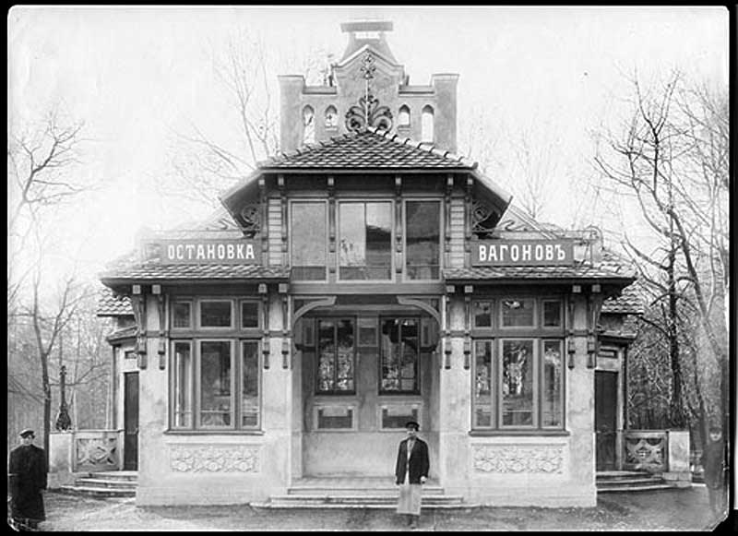 | 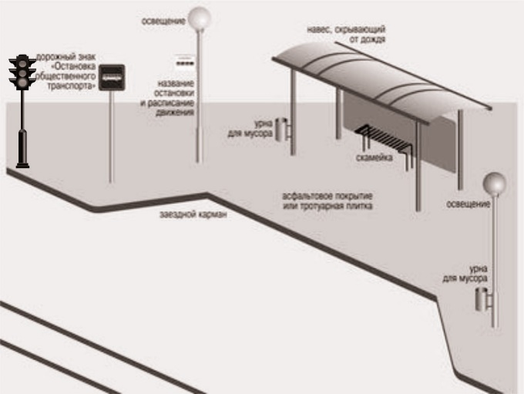
Picture 1. Stopping is at Petersburg | Picture 2. General technical requirements

The research in this article was conducted with the use of the materials on the organization of a comfortable environment for people with disabilities [9, 10], the need to maintain security for the population [11, 12], the need landscape of literacy in conducting research [13 - 20].

4. Discussion.
An online survey among residents of Vladivostok aged 18-65 revealed that 51 percent of respondents use public transport every day, almost thirty percent use 4-5 times a week, and only 9.5 percent of respondents chose the answer "rarely". According to the survey, it was also known that half of the regular users of public transport spend on bus stops waiting for the bus from 10 to 25 minutes, and a fifth of the respondents - more than half an hour, and if this time a person is forced to spend in uncomfortable conditions, it can cause stress. In addition, the vast majority of respondents – 70 percent – are dissatisfied with the level of equipment of bus stops.
Among the listed requirements for improving the functionality and equipment of bus stops, the main emphasis was placed on more detailed and thoughtful preparation of objects for the winter period: to increase the number of closed stops, to design warm rooms for waiting, as well as to improve their comfort in general – to make seating more comfortable, also to increase their number, to add canopies and lighting systems.
To obtain more objective information, Vladivostok stops were analyzed: Nekrasovskaya, Molodezhnaya, Postysheva (pic.3), Park Pobedy (pic.4), Vtoraya Rechka, Detskaya poliklinikal – according to the following parameters: compliance with the size of the passenger load stop at rush hour, compliance of structural objects with the requirements specified in GOST by the presence of the following elements [5. Page 2]:
- stopping strip
- landing site
- waiting areas
- travel pocket
- dividing strip
- sidewalk and footpath
- pedestrian crossing
of automobiledom
- benches
- toilet's
- containers and litter bins
- technical means of traffic management
- lightings [6. Page 4].
As well as how these elements correspond to the parameters specified in the GOST.
The analysis revealed the following inconsistencies with the technical requirements.
1. Nekrasovskaya stop (on the line of traffic from the city) in rush hour should take more than twenty people, and its size does not correspond to the comfortable location of so many people. The landing area, though present, but its width does not correspond to GOST (less than three meters). The dividing strip is not marked. The material of the bench in the pavilion does not meet the requirements. There is no toilet near the bus stop.
2. Nekrasovskaya stop (on the line of traffic to the city) at rush hour should take more than twenty people, but from the designed pavilions there is only one that in bad weather will not accommodate all passengers in need of shelter. The benches of the pavilion are made in metal, respectively, in the cold season, their use is difficult. In the spring-summer-autumn period road signs hides the leaves of trees.
3. Molodezhnaya stop at rush hour takes up to 18 people, and the only pavilion stop is able to accommodate no more than ten, respectively, in bad weather, passengers will have nowhere to hide. The landing area and the waiting area are almost completely destroyed, the curb does not separate the roadway from the landing point, which increases the risk of injury. There is no sign of a pedestrian crossing, a Board with a schedule, a dividing strip.
4. At the Vtoraya Rechka stop there is no dividing strip, and the travel pocket is smaller than the required size, respectively, does not fulfill its main function.
5. Detskiy Sad stop does not meet any technical requirement. And this is not the only example.
6. Postysheva stop generally meets the standards, except for the lack of a toilet and a dividing strip.
Summarizing the information, please note that all analyzed stops do not meet the technical requirements, and some stops are designed with gross violations of GOST. Absolutely all stops are devoid of strictly regulated toilets, most – there is no dividing strip. Many of the requirements are met formally, with a thorough analysis of visible shortcomings and negligent attitude of designers and builders. The quality of materials is low. Obviously, user comfort and aesthetic appeal of objects Domino transport infrastructure was not a priority for developers. (pig.3).
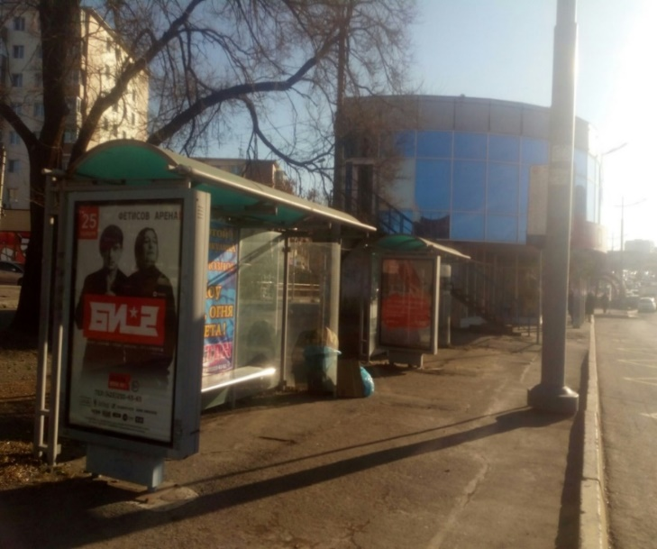 | 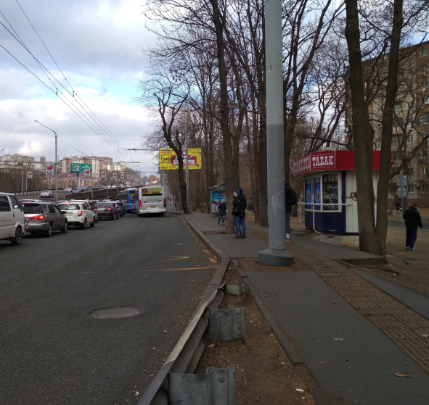
 | Picture 4. Vtoraya Rechka stop? on the line of traffic from the city
  Picture 3. Postysheva stop, on the line of traffic from the city

Summarizing the information, please note that all analyzed stops do not meet the technical requirements, and some stops are designed with gross violations of GOST. Absolutely all stops are devoid of strictly regulated toilets, most – there is no dividing strip. Many of the requirements are met formally, with a thorough analysis of visible shortcomings and negligent attitude of designers and builders. The quality of materials is low [7. Page 9]. Obviously, user comfort and aesthetic appeal of objects Domino transport infrastructure was not a priority for developers.

5. Conclusions.
The modern world is developing by leaps and bounds in the direction of information and aesthetic. Today, there are enough examples when the bus stop is equipped with interactive displays that allow you to study traffic patterns, USB-sockets, Wi-Fi access points, that is, along with its direct functions, it performs the functions of a telecommunications center (Vancouver, Canada), libraries – with bookshelves, relaxation areas - with a small roof garden, galleries of modern art – with exhibits of local artists (Singapore), there are examples of stops with air conditioning – (Florida, USA). In Russia, examples of such high-tech innovations are, alas, negative: passengers carry heaters, litter, break windows [7. Pages 10-12]. Attempts to make bus stops more comfortable in the Penza region and Krasnoyarsk region failed (pic.5,6).
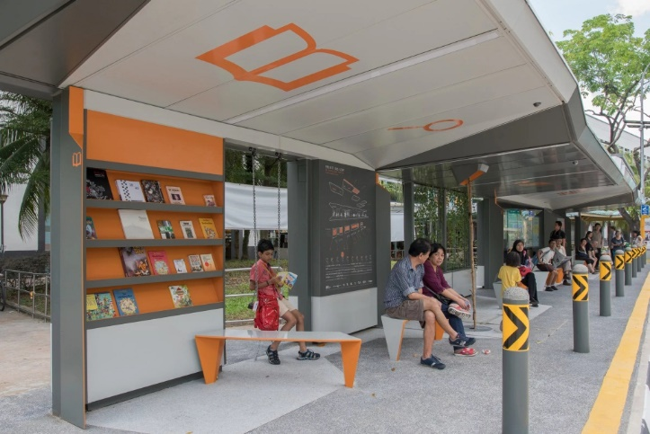 | 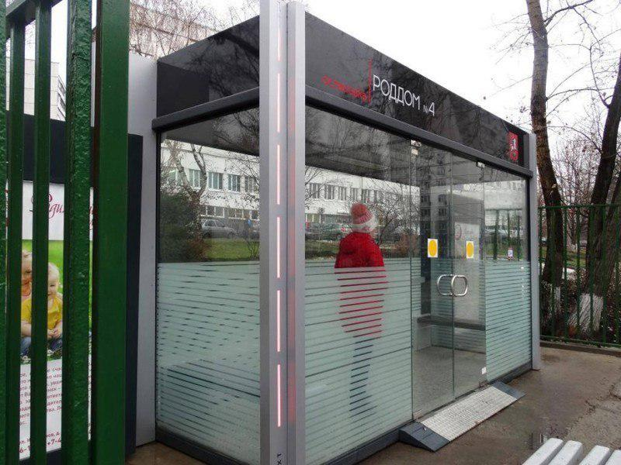
Picture 5. Bus stop is at Singapore | Picture 6. The warm bus stop is at Penza

Therefore, in conclusion, it should be noted that the city is a living system, where all the elements are in constant dynamic interaction with each other. Behind every phenomenon lies culturally programmed optics: a person influences visual reality, and it affects a person. These general recommendations for improving the level of comfort and aesthetic appeal of road transport infrastructure facilities are only the first step in changing the conceptual approach to the city as a living system, where all elements should work for the main goal – the embodiment of a harmonious and comfortable social environment [8. Page 1].

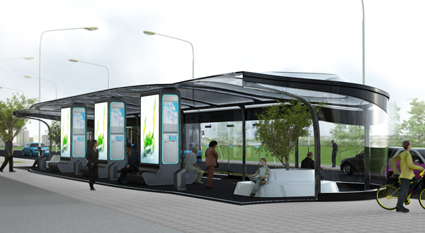
Picture 7. By the designers of the Saint Petersburg studio "In.Style" was worked out innovative project of stop complex, for an above-ground public transport, plugging in itself possibility not only to execute the basic functions of defence of passengers from a rain but also envisaging modern facilities of defence and comfort.

Third-year students of the direction of training "Design" within the disciplines "fundamentals of ergonomics in environment design" and "Design in environment design" performed a balanced analysis and proposed a competent design solution, which was considered in the administration of the region at the youth parliamentary Assembly at the Legislative Assembly of Primorsky Krai on June 11, 2019.
It should be noted that the study proposed the most basic measures to eliminate the basic contradiction – the existing elements of road transport infrastructure do not fulfill their direct purpose, do not become a zone of comfortable pastime of passengers while waiting for the vehicle. In the future, when designing, it is desirable to focus on world design practices and create infrastructure facilities with high functional and aesthetic quality, so that Vladivostok is rightfully considered the flagship of modern Russia in the APR.

References
1. Electronic resource www.cddc.vt.edu/sionline/
2. Basics of ergonomics in environmental design: a tutorial/L. A. Chernavina. – Vladivostok: Publishing house VGUES, 2009. – 262 p.
3. Electronic resource https://studfiles.net/preview/5918217/page:2/
4. Electronic resource https://aboutdata.ru/2017/03/17/busstop/
5. 218.1.002 OST-2003 the Bus stops on the roads. General technical requirements.
6. SNiP 21-01-97*. Fire safety of buildings and structures. 7. Electronic resource https://novate.ru/blogs/061211/19502/
8. Electronic resource: https://www.gazeta.ru/auto/photo/pervaya_teplaya_avtobusnaya_ostanovka_v_moskve.shtml ahhh!
9 ODM 218.2.007-2011. Guidelines for the design of measures to ensure access of persons with disabilities to road facilities. – M., 2013. – 96 p. Introduction. 17.06.2013.
10. SP 59.13330.2012 Availability of buildings and structures for people with limited mobility. Updated version of SNiP 35-01-2001 (with Change N 1).
11. GOST 12.1.004-91. Occupational safety standards system (PRS). Fire safety. General requirements (with Change N 1).
12. Mikhailov A. Yu. Organization of construction. Calendar and network planning [Electronic resource]: Textbook / Mikhailov A. Yu. - Vologda: Infra-Engineering, 2016. - Mode of access: http://znanium.com/catalog.php?bookinfo=760126
13. SNiP III-10-75. "Landscaping" / Gosstroy of Russia. – M.: sue BSC, 2003. — 38 p.
14. Koroteeva, Larisa Ivanovna. Basics of artistic design: studies for University students / L. I. Koroteeva, A. P. Yaskin. - M.: INFRA-M, 2015. - 304 p. - (Higher education: Bachelor)
15. Life safety: questions and answers, tasks and solutions: Study guide for students. higher educational. / Ed. A. G. Gorbunov, V. I. Dyakov, V. N. Larionov and others; ed. by V. Popov. - Ivanovo: Publishing house Ivan. State. ENERG. UN-t, 2000. - 407s.
16. Landscape design: studies manual [for University students] / [ed.: O. V. Khrapko, O. G. Ivanov, A. V. kopyeva, etc.] ; Vladivostok. state University of Economics and service, far Eastern Federal University, Nerd. sad-in-t Feb RAS - Vladivostok : publishing House VGUES , 2017 - 368 p.
17. Markov, Yuri. Rock gardens, slopes, rock gardens / EB Mar-kowski - M. : Fiton XXI , 2015 - 224 c. : Il.
18. Maslovskaya, O. V.. The design of the urban environment : proc. manual for University students, training. on sent. training 54.03.01 "Design" (bachelor) / O. V. Maslovskaya ; Vladivostok. state UN-t of economy and service - 2nd ed., additional - Vladivostok : publishing House VGUES , 2015 - 214 p.
19. Potaev Georgy Alexandrovich. Landscape architecture and design: Learning in the expedient [Electronic resource] , 2015 - 400 - Mode of access: http://znanium.com/go.php?id=509812 5
20. Potaev, Georgy Alexandrovich. Composition in architecture and urban planning: studies. a textbook for students of universities / G. A. Poteev - M : FORUM : INFRA-M , 2015 - 304

