Analysis of the Results of The Far Eastern Customs Administration Activities in the Context of Digitalization as the Basis for Choosing the Directions for Its Development
Elena A. Barausova (0000-0003-1833-1564)¹, Yuliya S. Lebedinskaya (0000-0002-7573-1372)¹, and
Evgeniya A. Nigay (0000-0003-0858-5835)^{1(*)}
¹ Vladivostok State University of Economics and Service, Vladivostok, Russia
barausova_elena@mail.ru, yuliya.lebedinskaya@vvsu.ru, jenia_nigay@mail.ru
Abstract. Currently, there are favorable conditions for improving the system of public administration, improving the quality of public services to the population and organizations based on the widespread use of information technologies in the activities of federal public authorities. The paper aims to analyze the results of the Far Eastern Customs Administration activities based on employing information technologies in its activities. The research methods include comparative analysis of scientific discourse, theoretical analysis and synthesis of research, and the method of analyzing documents and statistical data. The analysis of information-technical support for the activities of customs authorities carried out in the paper reveals opportunities for development and significant shortcomings and unresolved issues, which allow the authors to propose measures to eliminate them. The research relevance and scientific novelty consist in developing digitalization measures for the effective operation of the Far Eastern Customs Administration, based on blockchain technology, semantic data verification, and utilizing server infrastructure. The paper focuses on proposing the transition to blockchain technologies based on the flow of data and the sequence of their processing in separate information blocks. Undoubtedly, it can become an effective tool for solving existing and emerging issues that hinder digital development in an organization under study. Namely, it will solve the issue of high load on the servers of customs checkpoints and eliminate such consequences as long processing of data, information, documents, declarations for goods. It will minimize the occurrence of technical information failures, which, in turn, will affect the reduction of the terms of customs operations.
Keywords: Digitalization ∙ Information technologies ∙ Analysis ∙ Assessment ∙ Customs authorities ∙ Far Eastern Customs Administration ∙ Problematic areas ∙ Directions for development ∙ Blockchain technologies

Introduction
The Far Eastern Customs Administration is the largest regional department of the Federal Customs Service by the occupied territory. The area of responsibility of the Administration includes 11 constituent entities of the Russian Federation that comprise the Far Eastern Federal District.
The Far Eastern Customs Administration, along with all structural divisions of the Federal Customs Service of Russia, actively use information customs technologies in their activities, constantly improve their activities to achieve the strategically important tasks and goals set for the entire customs system (Prokhorov & Konik 2019).
The result assessment and analysis of the Far Eastern Customs Administration activities in the context of digitalization implements the following factors:
- Assessment of external factors (macroeconomic factors and conditions) – the volume of trade turnover, exports, and imports of goods in the Far East;
- Assessment of factors of internal development of the customs regulation sphere – the number of participants in foreign economic activity in the Far East and the volume of the declaration array issued in the Far Eastern Customs Administration;
- Assessment of information blocks – target indicators of employing automated information technologies, the quality index of control, and supervisory measures carried out using information technologies (Starkova, 2007).

Materials and Methods
The research goal is to assess and analyze the results of the Far Eastern Customs Administration activities in the conditions of digitalization.
The research aims at analyzing external and internal factors that influence the development of customs activities, assessing the development of digitalization in the Far Eastern Customs Administration activities.
The information base of the study is the Rosstat, Primorskstat, and the Far Eastern Customs Administration website data.
The research methods include comparative analysis of scientific discourse, theoretical analysis and synthesis of research, and the method of analyzing documents and statistical data.

Results
One of the external factors of the Far East that has a direct impact on the results of the activities of the Far Eastern Customs Administration is the growth of trade turnover. Fig. 1 depicts the dynamics of the primary indicators of the Far East development in 2017-2019.

Fig. 1. Dynamics of the primary indicators of the Far East development in 2017-2019, in millions of US dollars. Source: (Federal State Statistics Service [Rosstat], 2020).
In the current conditions of economic growth in the Far East, which require strengthening the control and supervisory, administrative, regulatory, and other functions of the customs authorities of the region, it is impossible to avoid technological approaches in managing the activities of the Far Eastern Customs Administration (the territorial body of the Federal State Statistics Service for Primorsky Krai [Primorskstat], 2020). Another equally significant factor in the development of the Far Eastern Customs Administration has been the increase in the number of participants in foreign economic activity in 2019 by 13% (approximately 14,000 in total) due to the use of electronic declaration technology. Due to the applied technology, the number of declaration arrays issued in the Far Eastern Customs Administration has increased (Fig. 2).
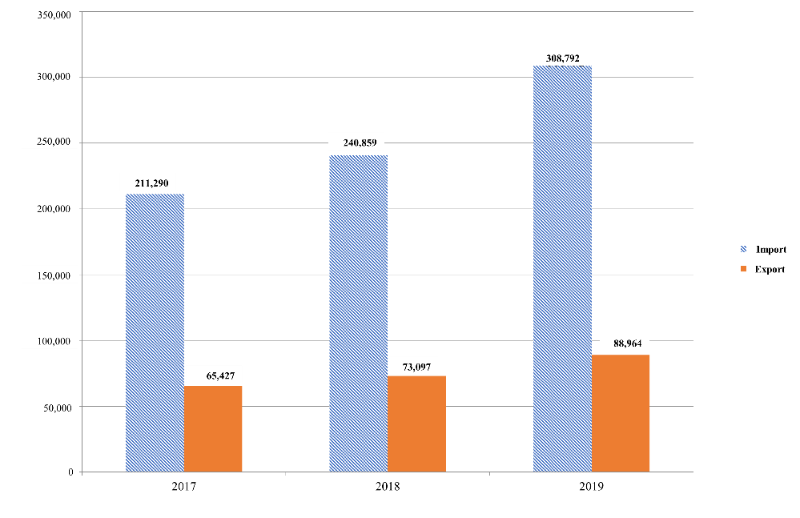
Fig. 2. Dynamics of declarations for goods registered and declared in the Far Eastern Customs Administration in 2017-2019, in items. Source: (Far Eastern Customs Administration [FECA], 2021).
The advantages of electronic declaration for the activities of customs authorities are a reduction in the speed of processing goods and the ability to inform the internal customs authority about the results of checking the original document (Blizkiy, Malinenko & Lebedinskaya, 2021).
In parallel with the development of electronic declaration centers, technologies aimed at achieving automation of decision-making during the registration of goods are being actively introduced, namely, technologies for automatic registration of declarations and automatic release of goods, including for the customs procedure of customs transit (Margarov, Mitrofanova & Anikeeva, 2021).
Practical implementation of the automatic registration of Goods Declaration technology (hereinafter referred to as AR) and the technology of automatic release of goods (hereinafter referred to as ARG) in relation to all Far East goods declarations (low-risk participants, three groups – low, medium and high risk) has been executed since 2017. Nevertheless, with the creation of electronic declaration centers, the development of technologies for automatic registration and release of goods has become possible (Fig. 3).
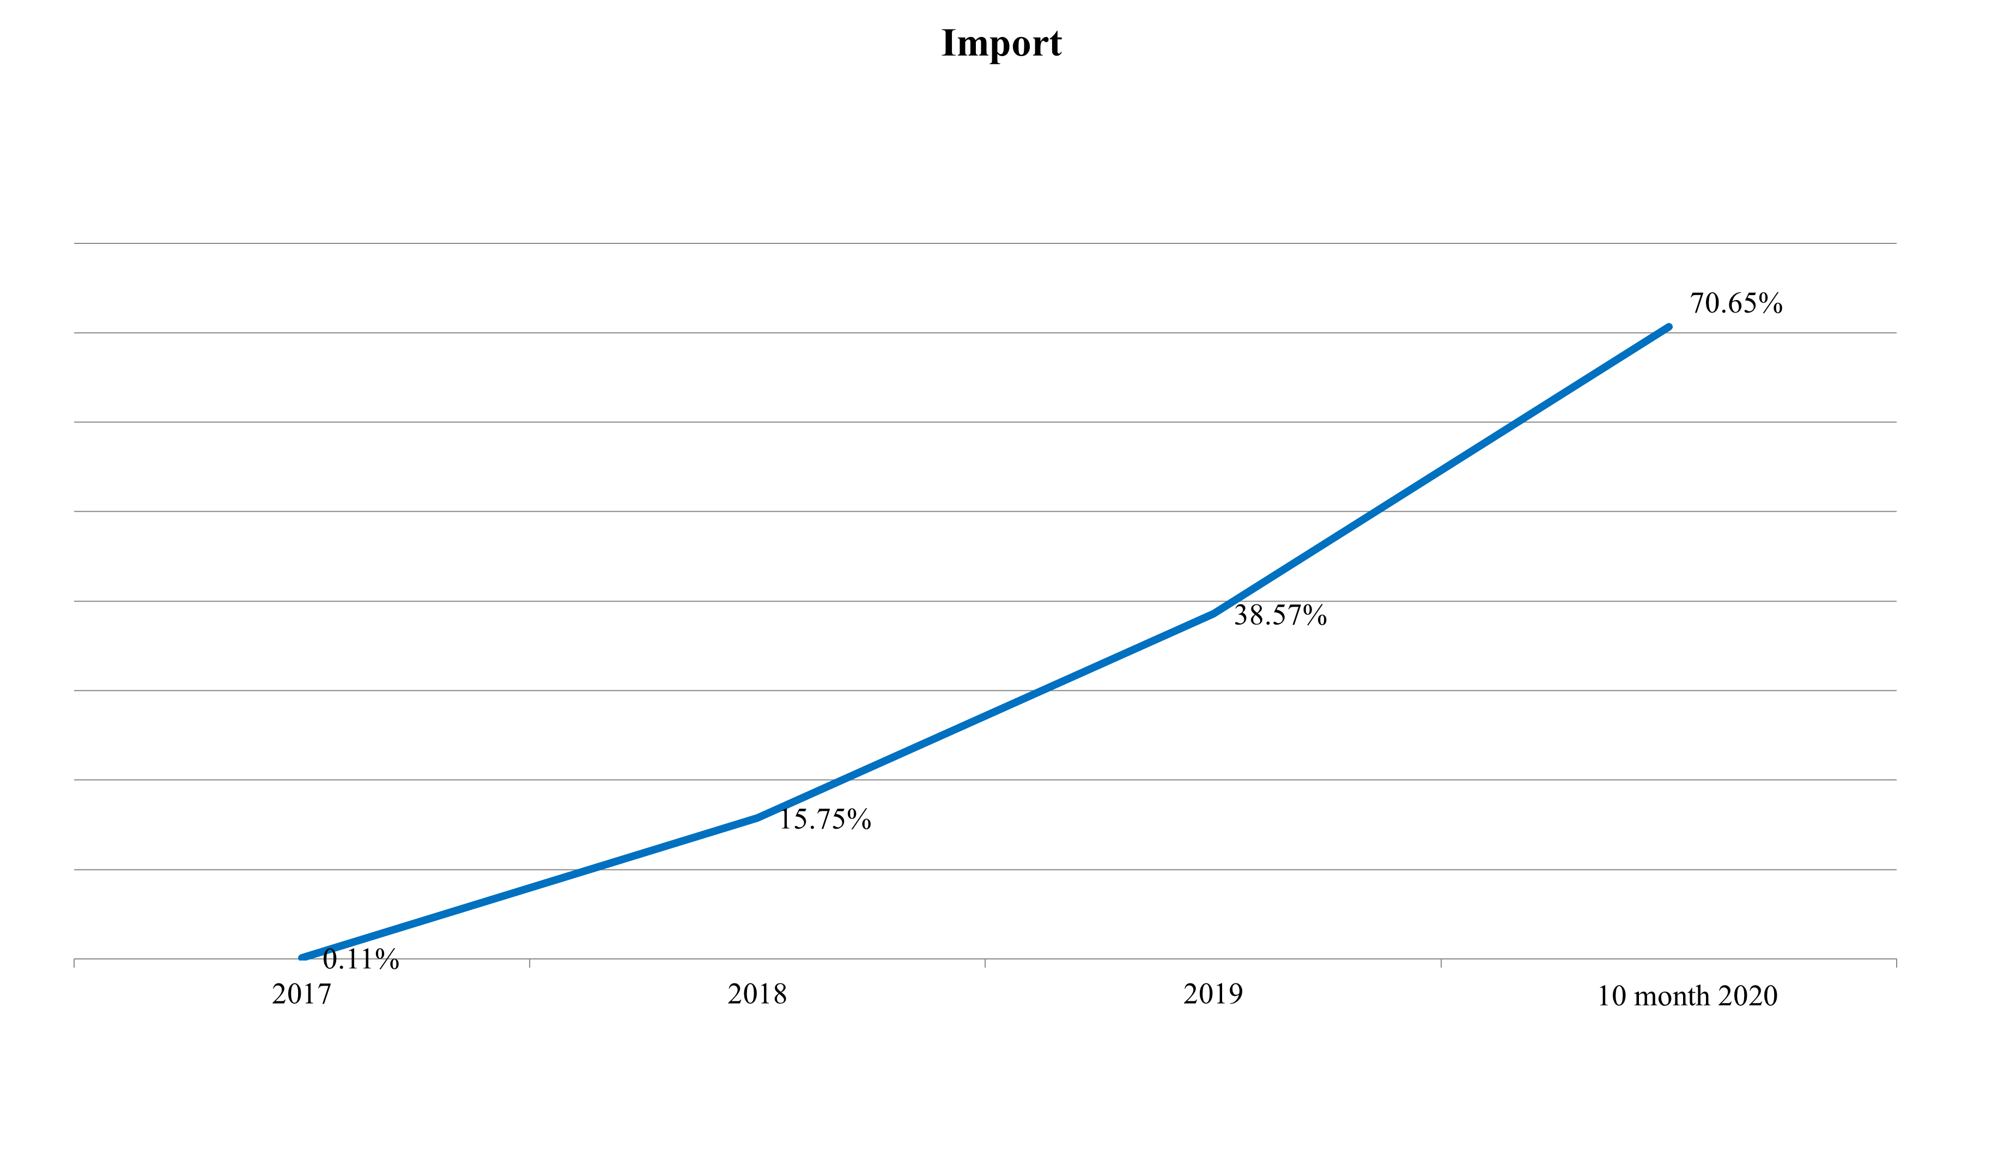
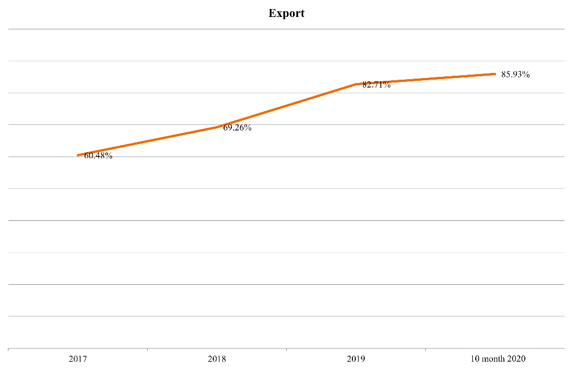
Fig. 3. Dynamics of development of the technology of automatic registration of AR in the Far Eastern Customs Administration (FECA) in 2017-2020, in %. Source: (Far Eastern Customs Administration [FECA], 2021).
In comparison with 2019, in 2020 (as of October 2020), the Far Eastern Customs Administration (FECA) achieved the following values in the implementation of auto-registration technologies:
- The share of imported AR increased by 32% and amounted to 70.7% or 191 thousand AR (the target indicator was 71 %) of the total import declaration array of FECA;
- The share of exported AR increased by 3.2% and amounted to 85.9% or 61 thousand AR (the target indicator was 89 %) of the total export declaration array of FECA.
Positive dynamics was also revealed in relation to the technology of automatic release of goods:
- The share of imported AR increased by 6.5% and amounted to 11.12% or 30 thousand AR (the target indicator was 76 %) of the total import declaration array of FECA;
- The share of exported AR increased by 5.3% and amounted to 15.84% or 11 thousand AR (the target indicator was 84 %) of the total export declaration array of FECA.
Since October 28, 2019, it has been possible to automatically register electronic transit declarations (hereinafter referred to as ETD) in all authorities of the FECA, which are competent to perform customs operations related to placing goods under the customs procedure of customs transit, regardless of the type of transport. Additionally, since the beginning of 2020, the gradual introduction of the technology of automated release of goods within the customs procedure of customs transit has been introduced. Despite the short duration of utilizing these technologies, it is currently possible to assess their development (Fig. 4).
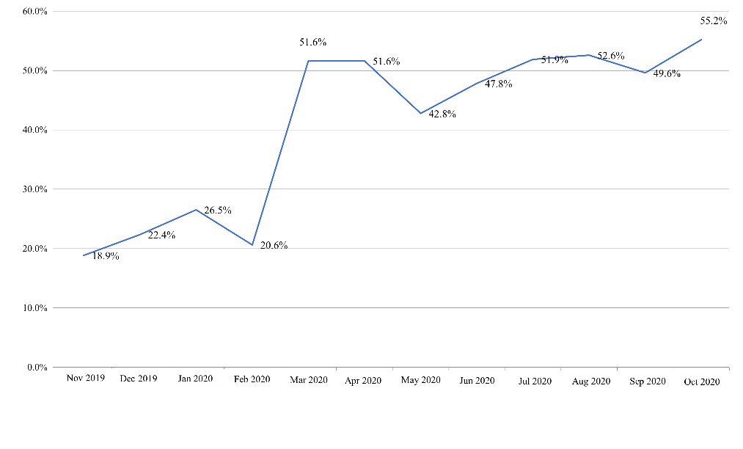
Fig. 4. Dynamics of utilizing the AR ETD technology in FECA (November 2019–October 2020). Source: (FECA, 2021).
In the Far Eastern Federal District, 23,479 ETDs were issued in October 2020, out of which 12,964 were automatically registered, which was 55.2% (an increase by 36.3% compared to November 2019). Furthermore, 5,046 ETDs passed the automatic issue, which was approximately 21.5% of the total number of ETDs that passed the verification of the criteria for compliance with the conditions of automatic registration.
Suppose one assesses the impact of the technology of automatic registration of declarations on imported and exported goods declared by participants of low-risk foreign economic activity, then according to the “established targets” block. In that case, the achievement of targets in 2019 (60% for imported AR and 70% for exported AR) is 100% (the achieved values in 2019 for import and export are 61% and 90%, respectively).
Analyzing the achieved values of the indicators of utilizing the automated technologies in the activities of customs authorities, one should note the influence of such a factor (which is an element of the assessment mechanism) as the submission of electronic preliminary information about goods and vehicles before they cross the customs border.
The quality of providing preliminary information depends on how quickly and effectively the risk assessment for the declared goods will be carried out, and, accordingly, the possibility of making an automated decision increases (Blizkiy, Malinenko & Lebedinskaya, 2021). Nevertheless, preliminary informing is relatively labor-intensive for implementation due to an extensive list of manipulations for collecting and filling in heterogeneous information (the license of the transport vehicle, the time and place of delivery, etc.).
The analysis makes it possible to identify problematic areas in the activities of the Far Eastern Customs Administration (Table 1) and proposes measures to eliminate them.
Table 1. The problematic field of development of the Far Eastern Customs Administration.
Problematic areas | Detailing the problematic area
Electronic declaration, EDC | Requirements for a high level of document formalization;  Insufficient training of officials;  High server load (increased processing time, technical failures).
Customs administration | Terms of customs operations.
Customs control | Insufficient effectiveness of customs control when transporting goods and vehicles across the customs border, including post-release control;  Control of the customs value.
The system of interdepartmental interaction | Low level of information interaction with other government authorities in the field of foreign economic activity.
Information space of customs authorities | Threats of unauthorized access to the unified automated information system of customs authorities from the global information space.
Source: Compiled by the authors.
In accordance with the identified problematic areas of the Federal Customs Service of Russia and, in particular, the Far Eastern Customs Administration, considering the planned activities (development strategy until 2030), the following directions of its development can be proposed.
First of all, in order to optimize the processes (from the stage of acceptance of the goods declaration to its release) that occur based on electronic declaration centers, there is a need to transform them into an element of blockchain technology. The primary principle of blockchain technology is the distribution of a decentralized register of data processed by specified mathematical algorithms, resulting in the same result for all system users. The advantage of such a system is the simultaneous openness and security of information – the issue of information security threats will be partially or entirely eliminated (the fifth problematic area). Blockchain technology will also allow tracking the movement of goods and vehicles along the entire logistics chain, which, in turn, will increase the efficiency of customs control (the third problematic area). Another advantage of blockchain is the ability to solve the issue of interdepartmental interaction (the fourth problematic area).
Second, one should introduce semantic verification of goods declarations (an algorithm for sequential verification of the words of the text). The semantic analysis will allow one to improve such problematic areas as the electronic declaration, namely the requirement for a high document formalization and customs administration (the timing of customs operations).
Third, there is a need to organize additional training courses, training on working with software tools, information systems, building electronic queries, etc., which will eliminate the issue of insufficient personnel qualification.
Fourth, there is a need to develop the necessary server infrastructure to implement and operate technological developments, including blockchain. In turn, this factor will solve the issue of high load on the servers of customs checkpoints and eliminate such consequences as long information processing times, documents, goods declarations, and minimize the occurrence of technical failures.

Discussion
Statistical data and the analysis research allow the authors to draw the following conclusions. Over the past ten years, large-scale work has been done to introduce new information technologies into the processes of customs declaring and customs control and their complex automation. Priority measures have been taken to provide information and technical support for transferring customs accounts for servicing to the Federal Treasury authorities. The development of information exchange organization in the new system of placement and subordination of customs authorities has been completed. The organizational and staff structure of the divisions of the information and technical service of customs authorities and the vertical of their management have been formed. Work on developing a unified automated information system has been launched to optimize and improve the quality of customs administration.
Simultaneously, there are significant shortcomings and unresolved issues in the activities regarding information-technical support for the customs authorities. The equipment and commissioning of complex automated customs declaring systems in customs offices with the highest activity intensity and work on the introduction of departmental e-mail and electronic document management are being implemented at an insufficient pace. The problem of complete coverage of customs authorities by an automated system for controlling the delivery of goods continues to be urgent. The level of equipment of customs authorities with technical and software tools has not yet met current requirements. There is still an outflow of trained, experienced personnel from the departments of the information-technical service of customs authorities. Coordination in matters of financial and economic support of the events being held needs to be strengthened.
Therefore, the proposed transition to blockchain technologies based on Big Data and the sequence of their display in separate information blocks can undoubtedly become a source of solving existing issues that hinder the digital development of the Federal Customs Service of Russia and, particularly, the Far Eastern Customs Administration.

Conclusion
Based on the analysis of utilizing the information technologies in the activities of customs authorities, the authors can confirm the effectiveness of management decisions made within the framework of the development strategy of the Federal Customs Service of Russia. However, the process of implementing information technologies is not hindered, which has not been considered when developing recommendations for the development of the Far Eastern Customs Administration within the framework of digitalization of activities.
In the current situation of contradictions and, simultaneously, potential and opportunities, there is a need to develop tools for regulatory actions to introduce digital technologies in the activities of customs authorities. Their basis should be a comprehensive assessment of the achieved and forecasted results. It will increase the management efficiency.

References
Blizkiy, R. S., Malinenko, V. E., & Lebedinskaya, Y. S. (2021). Iterations of digital transformation of human capital in the development of economic growth drivers. Socio-Economic Systems: Paradigms for the Future, Studies in Systems, Decision and Control, 314, 1319-1328.
Blizkiy, R. S., Malinenko, V. E., & Lebedinskaya, Y. S. (2021). Recursion of the temporal paradigm of the digital economy accounting. Socio-Economic Systems: Paradigms for the Future, Studies in Systems, Decision and Control, 314, 521-529.
Far Eastern Customs Administration (FECA). (2021). Retrieved from https://dvtu.customs.gov.ru/ved
Federal State Statistics Service (Rosstat). (2020). Retrieved from https://rosstat.gov.ru/folder/512
Margarov, G. I., Mitrofanova, E. A., & Anikeeva, L. V. (2021). Formation of a justified strategy of education in the sphere of information security in the digital economy. Socio-Economic Systems: Paradigms for the Future, Studies in Systems, Decision and Control, 314, 15-22.
Prokhorov, A., & Konik, L. (2019). Digital transformation: Analysis, trends, world experience. Moscow, Russia: AlyansPrint.
Starkova, O. A. (2007). Quality management of services provided (Dissertation of Candidate of Economic Sciences). Saratov, Russia: SSEI.
Territorial body of the Federal State Statistics Service for Primorsky Krai (Primorskstat). (2020). Retrieved from https://primstat.gks.ru/stat_otchet

