Method for scanning probe microscopy images analysis for evaluation of topographic
parameters of objects on the surface

Semyon Balagan
Institute of Automation and Control Processes FEB RAS
Russia
simak_64@mail.ru
Evgeniy Chusovitin
Institute of Automation and Control Processes FEB RAS
Russia
eliot@list.ru
Dmitry Goroshko
Institute of Automation and Control Processes FEB RAS
Russia
goroshko@dvo.ru
Olga Goroshko
Vladivostok State University Economics and Service
Russia
olga.goroshko@vvsu.ru

Abstract — Currently, scanning probe microscopy (SPM) is actively used to obtain surface data. A large number of images require a fast and high-quality calculation of the topographic parameters of objects on the surface. The original algorithm for finding the local maximum is realized by sorting an array of points forming the topography of the SPM image surface. It provides to determine any topographic characteristics of the surface and objects located on it (height, lateral dimensions, area, volume, etc.)
Keywords — scanning probe microscopy; grain analysis; topographic characteristics

Introduction
Currently the technologies for obtaining and processing various data are developing rapidly, including nanoobjects located on the surface of the substrate. Scanning Probe Microscopy (SPM) is a high-tech method of obtaining surface data. There are several software products on the market for processing of SPM images [1-5], but the practice of their use and analysis has shown that they are have shortcomings. So it is required to develop an algorithm and prepare a software module that will process and analyze the SPM images in order to obtain the topographic parameters of the objects on the surface.
The Grain Analysis module (GA) dedicated for processing and analyzing SPM images, is an essential part of the following programs: Gwyddion 2.25, Image Analysis 3.5.0.2066, Nova 1.0.26.1443, SPIP 5.0.7.0, FemtoScan Online 2.3.94 (5.1) Demo [6-9]. The GA software module delimits nano-objects and substrate and builds a mask (black and white image that is obtained by drawing a section of objects at a certain level relative to the substrate). Then the data are processed statistically. For example, it is possible to calculate the size and concentration of objects located on the surface, to determine the amount of surface occupied by objects, etc.
Unfortunately, the GA module from the mentioned programs does not work adequate. Not all nanoobjects are allocated, their size is determined incorrectly. Also, there is a strong dependence of the choice of algorithm on the type of working surface (smooth, with developed relief, etc.). Statistics is not reliable, even in the case of a proper mask. A mistake up to 30-40% for the coverage area could be obtained in the case of close-stuck islands; at least one lateral dimension is calculated wrong; the concentration and size of objects on the surface are calculated with errors on the noisy surface; it is impossible to obtain statistical data of extended objects, for example, organic polymer molecules. All this greatly affects the reliability of the results obtained during the research such as a dependence of the physical properties of the objects on their size or ordering on the surface.
Thus, there is a need to develop a software module GA, which allows the processing of SPM images with complex relief. It should reliably separate nanoobjects on the background of a considerable relief and determine their lateral and vertical dimensions with high accuracy.

Principle of operation
The basis of the developed algorithm is a taxonomy task implies the image dividing into areas followed by processing of each area depending on the properties of the selected cluster. Additional limitations must be fulfilled: only adjacent groups of pixels can be joined into the same group; the pixel groups must remain indivisible for the input data of this module. The developed algorithm is presented in the form of separate blocks, each of which solves its task without which the integrity of the method is impossible.

Image sharing
Consider a one-dimensional image where the pixels are arranged sequentially in the form of single row. Process the image so that each local maximum is associated with different colors. Then, the affiliation of the nearest points to the found local maximum is determined and, accordingly, their coloring becomes the color of the nearest extremum. As a result, we obtain a regionally divided image, where each color corresponds to a group of pixels. There can be from several hundred to several tens of thousands of such groups (Fig. 1). The groups obtained are numbered in descending order of the height of their maxima.
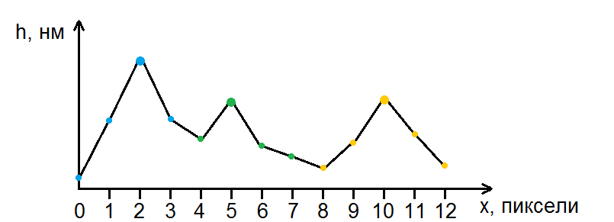
- Vertical cross section of an image with three islands. The color is assigned to each pixel allowing to group the pixels.

Automatic grouping of pixels
The considered algorithm of block 1 can be applied to groups of pixels (Fig. 2). Now we can quickly connect some groups into clusters and reduce their number (Fig. 3). This is useful when working with noisy images or images of objects that have multiple local maximums. Algorithm of "automatic connection of groups of pixels" estimates affiliation of one group of pixels to another.
Consider the two-dimensional case of the processed image (Fig. 4), the vertical cross-section of which is shown in Fig. 2. One can clearly distinguish three main groups of pixels as a result of the image sharing procedure. They are colored in yellow, green and blue.
Now it is necessary to determine the degree of the neighborhood of each group of pixels to the adjacent groups and distinguish whether these groups of pixels should be merged. For this, a numerical characteristic is introduced, determined by the ratio of the number of pixels of the group adjacent to the pixels of the other group to the total number of pixels adjacent to other groups or located on the border of the image (pixels of the perimeter of the group).
$ξ_{qp}=\frac{ε_{qp}}{φ_{q}}$ (1)
where p, q are indices of groups of pixels; ε_{qp} is the number of pixels of group q adjacent to group p; φ_{q} is the number of pixels of the perimeter of group q.
As a result of calculations, the set of numbers is obtained, which will help to impose a limit on the extent of the boundary between neighboring groups of pixels (Table 1).
We impose a restriction on the extent of the boundary between the joined groups of pixels ξ_{min}. If the parameter ξ_{min} is less than or equal to the value obtained, in this case 0.43, then the yellow and green groups can be combined (under adherence to other conditions of association). However, to make decisions about the association of neighboring groups, one parameter of the degree of neighborhood with other groups is not enough. We enter one more parameter, which shows the minimum height of the stage (H_{s}). It allows you to determine the levels (terraces) on which the islands are located, and select the pixels that are on the border of the groups.
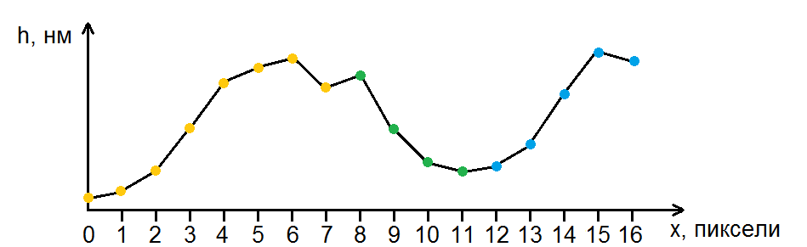
- Vertical cross section of the image with two islands. There are to maxima at pixel 6 and 7 that could be the real maxima or result of noise distortions.
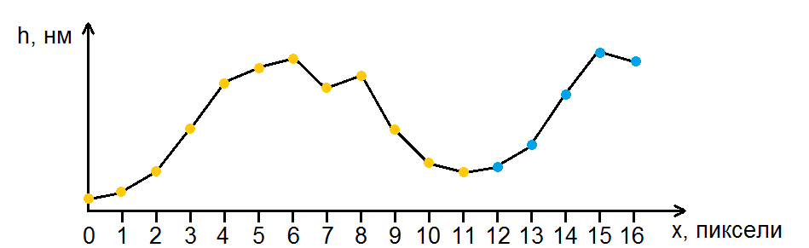
- Vertical cross section of the image of two islands. In case of local maxima are resulted from noise, yellow and green set of pixels are grouped to single one.
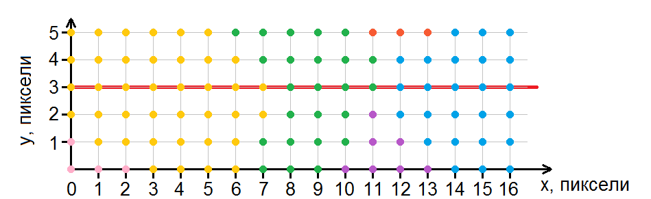
- Two-dimensional image (top view) with a result of the image sharing procedure. Each color corresponds to the separate group of pixels. Fig. 2 corresponds to the vertical section marked by the red line.
- Example of calculating of the $ξ_{qp}$parameters that determine the degree of neighborhood of the green group with others (Fig. 4). The highest degree of neighborhood with the yellow group.
Neighboring group, p | ε_{green p} | φ_{green} | ξ_{green p}
Yellow | 9 | 21 | 0.43
Blue | 3 | 21 | 0.14
Red | 2 | 21 | 0.12
Purple | 4 | 21 | 0.19
Consider two groups of pixels on a one-dimensional image which are located on different terraces. Denote the height of the pixels in the perimeter of the group p h_{p0}, h_{p1}, …, h_{pq} (q is the number of the pixel). Then find the highest h_{pm} among h_{p0}, h_{p1}, …, h_{pq}. After this, exclude from the group the pixels q for which h_{pm} - h_{pq} > H_{s} by removing the color (a special group of colorless pixels is formed). Since the perimeter of the group has changed, we will repeat the search for the highest point and the exception until the number of pixels in the group stops to decrease. For example, if H_{s} = 5 nm we obtain Fig. 5 after sequential numbering and excluding pixels from groups. This allows to determine the level on which the island is located more accurately.
Further excluded (discolored) pixels are removed. The possibility of association of islands is estimated. Fig. 6 shows the case where the groups of pixels are not merged.
The islands (or other objects that need to be analyzed) often located on the boundaries on real surface images. Let us consider how to interpret the height of boundary pixels in such objects. The problem easily can be solved if we exclude from consideration such objects. However, it is not possible in case of extended objects that intersect several boundaries of the image, unique objects, etc. If border objects are to be left, then the perimeter of the pixels needs to be restored for such a border group. Consider the two-dimensional image (Fig.7) and denote the height of the pixels of the perimeters of the groups ω_{pq}. If the pixel of the perimeter of the group does not belong to the boundary of the image and is adjacent to the pixel of the other group that is on the boundary of the image, then its height is taken as the pixel height with the same indices: ω_{pq} = h_{pq}. Fig.7a shows an image divided into three groups of pixels. Border pixels for which ω_{pq} = h_{pq} have a purple outline (Fig.7b).
The new perimeter must be "restored" for the pixels that belong to the edge of the group and coincide with the boundary of the image. The perimeter should restore the line, which is the intersection of the surface on which the object is located, and the plane of the section of the object by the image boundary. Linear interpolation of pixel heights will do this in the simplest case. The outer pixels of this group lying on the border of the image are taken as the base points for the interpolation.
Pixels of the image boundary should be placed on one straight line to determine ω_{pq} starting with the first pixel which is located on the boundary between two groups of pixels. For example, start with a pixel with coordinates (0; 3) and move clockwise (Fig.7a). The result is presented in (Fig.8) showing pixels arranged in the line that are on the border of the image in Fig.7a.
The resulting line consists of segments of different colors. Next, we calculate the ω_{pq} for each group. Let the first pixel of the series p have index 0, the last pixel n_{p}. Linear interpolation is performed for the remaining pixels to find ω_{pq} (q ∈ [1; n_{p}-1]):
$ω_{pq}=ω_{p1}+q\frac{ω_{pn_{p}}-ω_{p1}}{n_{p}}$ (2)
The number of pixels in the group is the last parameter that restricts the association with another group. This parameter allows to adjust the size of the groups of pixels that are obtained as a result of the described algorithm. The two adjacent groups of pixels will be stitched tougher if the number of pixels in any group is less than given.

Separation of objects from the substrate
The implemented GA program module must determine the parameters of nanoobjects located on the substrate and exclude the influence of the substrate itself on these objects. Consider an island located on a substrate with a macrorelief (Fig.9).
It is clear that surface distortion prevents direct determination of the island parameters (height, lateral dimensions, volume). It is required to subtract the surface that corresponds to the substrate to adjust the shape of the islands. This surface consists of small surfaces corresponding to each island. It should be mentioned that at this stage each island corresponds to a single group of pixels while the extra groups are discolored. The height of the discolored pixel will be zeroed when subtracting the plane.
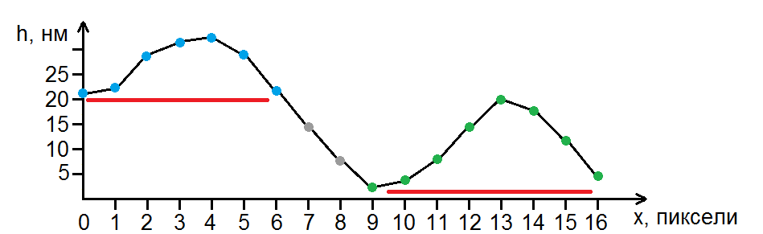
- Vertical cross section of two islands that are located on the neighboring terraces. Approximate levels of terraces are shown by red lines. The discolored (excluded) pixels are indicated in gray.
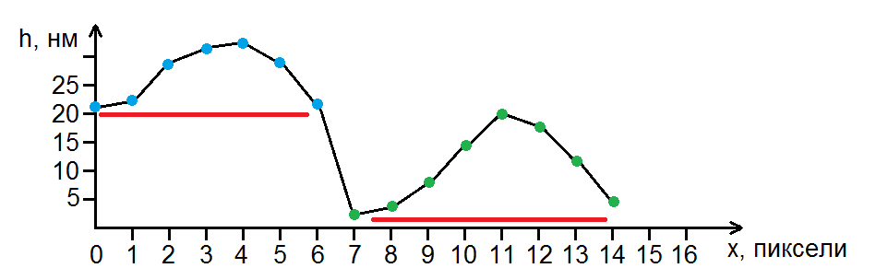
- Vertical cross section of two islands that are located on the neighboring terraces without excluded pixels. Approximate levels of terraces are shown by red lines.
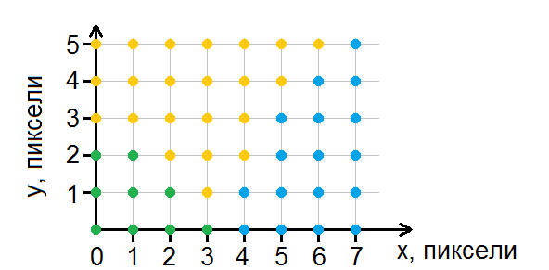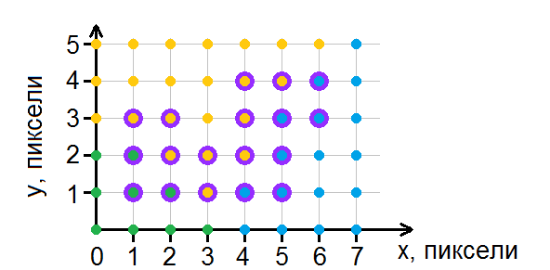
- (a) The image is divided into three groups of pixels. (b) Border pixels with a height ω_{pq} = h_{pq} are highlighted with a purple outline.
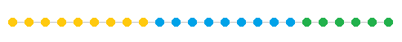
- Pixels, located on the border of the image (Fig. 7) are located on the same straight line starting from the pixel with coordinates (0; 3).
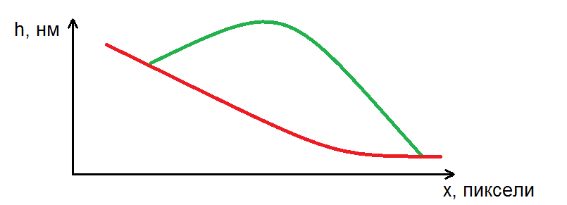
- Vertical section of the island on the substrate with a macrorelief. Green line denotes the surface of the island while red line – the surface of the substrate.
Let's consider the height of the pixel perimeter ω_{pq} (p is the group number, q is the pixel index) that was determined earlier. Next, calculate the plane using least squares method for each group of pixels on the basis of an array of coordinates and pixel heights of the perimeter of the group (ω_{pq}). In case of zero-order plane we seek for a pixel with the lowest height in each group of pixels followed by subtracting of the value from the height of all pixels in the group. After surface subtraction the image is ready for islands characteristics investigation.

Processing of stuck objects
Sometimes the objects on the surface are not completely separated for instance formation of islands that are stuck together under the influence of the growth conditions (Fig.10).
For simplicity let's assume that the substrate is a perfectly flat horizontal surface and the pixels of the island perimeters that are not adjacent to the pixels of the other island have a height equal to the height of the substrate. The remaining perimeter pixels have a height greater than the height of the substrate (this is a consequence of the fact that the islands are stuck together).
Calculate the subtracted plane for each island according to the algorithm described above. Obviously, the pixels located on the islands boundary will be lower than the calculated plane. Therefore, all the pixels above the calculated plane should be excluded from the calculation of the plane on the next step (Fig.11). The procedure of the calculation of the plane and exclusion of the pixels is repeating until the minimum value of the regression coefficient is reached or until a certain number of plane calculations and pixel exclusions are made (both parameters are set by the user). After that, the plane is calculated from the remained pixels. The height of the excluded pixels is calculated from the coefficients of the equation of this plane (ω_{pq}).

Definition of islands parameters
Currently, with the help of the program it is possible to estimate the following characteristics of the islands: height, area, volume and lateral dimensions. The last three characteristics depend on the relative level of the horizontal section (L ∈ [0; 1]) specified by the user. Introducing the relative horizontal section is required for determination of the height of the island as the distance from its base to the top while the area of ​​the island - on a section at the half maximum.
A determination of the islands parameters is performed using images of islands that are separated from the substrate. First, we determine the height of the island, finding its highest point. After this, we find the absolute level of the horizontal section of the island:
$Y_{p}=ψ_{p}L$ (3)
where Y_{p} is the absolute level of the horizontal section of the island p (nm); ψ_{p} is the height of the island p (nm); L is a relative level of the horizontal section (L ∈ [0; 1]).
Several local satellite maxima may exist close to the main one on highly noisy images within the same group. The decision if such maxima should be taken into account when determining the perimeter of an island is made using the island image mask. The heights of the pixels of an island is denoted by h_{pq} (p is the group number, q is the pixel index). The mask is formed using the following considerations: if h_{pq} ≥ Y_{p} then the pixel is colored white (the height of the point is one), otherwise the pixel remains black (the height of the point remains zero).
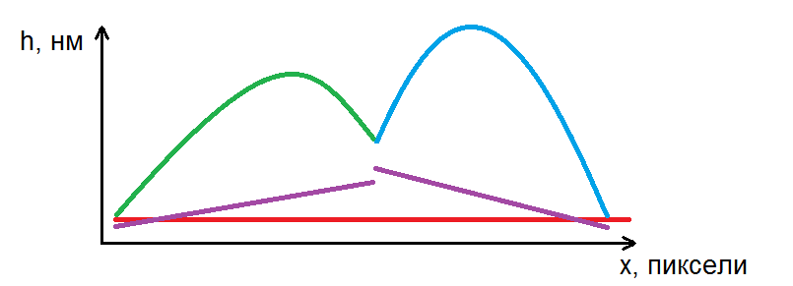
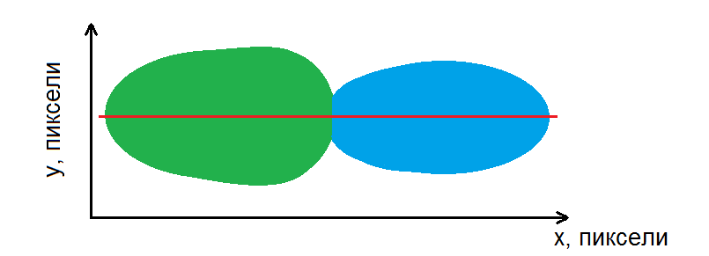
- Schematic image of the stuck islands. (a) - vertical cross-section of two coalesced islands (green and blue lines), which are located on a horizontal substrate (red line). The first order planes are indicated by purple lines. They are deducted by separating the islands from the substrate. (b) top view of the same islands. The vertical section corresponding to (a) is indicated by a red line.
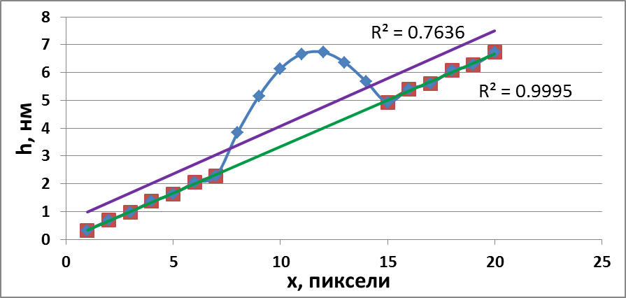
- Illustration of the elimination of pixels from the graph. Initial chart is a blue line. Violet line is calculated in the first step (R² = 0,7636). The green line (R² = 0,9995) is calculated after excluding of the points above the violet line.
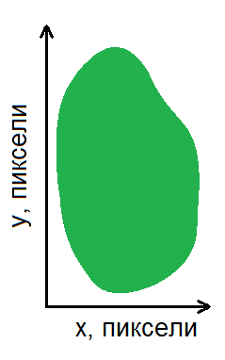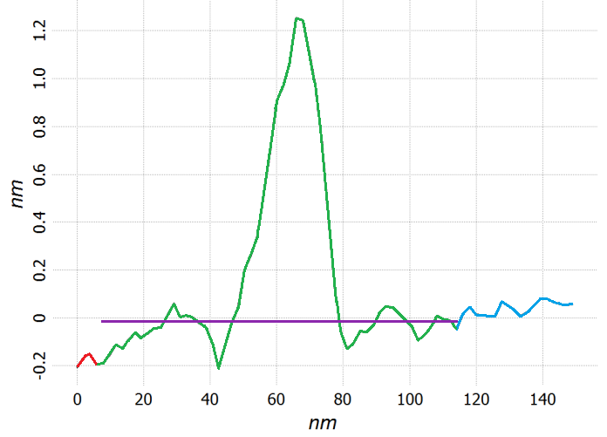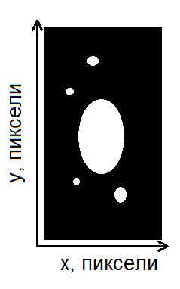
- An example of unconnected islands. (a) A group of pixels containing five local maxima. (b) Vertical cross section of surface close to the group in (a); green line corresponds to the pixels which belong to the group in (a); purple line denotes the absolute level of the horizontal section. (c) An example of the mask that can be obtained from the group; a large ellipse corresponds to an island; small ellipses correspond to local peaks close to the island.
Since noises and irregularities on the surface within a single group can be large enough to affect the size of the island, it is required to check if all the pixels of the island mask are connected or not. In the case of the presence of unconnected regions (Fig.12) the white color is kept only for region containing the highest pixel; others are excluded from consideration.
After the mask formation, it is possible to calculate volume of the island and its base area. For this purpose, the number of pixels with h_{pq} ≥ Y_{p} is calculated followed by calculation of their heights:
$V_{p}=H_{∑p}⋅Δx⋅Δy$ (4)
$S_{p}=N_{p}⋅Δx⋅Δy$ (5)
where V_{p} is the volume of the island p (nm³); S_{p} is the area occupied by the island (nm²); H_{∑p} is the sum of h_{pq} for which h_{pq} ≥ Y_{p} (nm); N_{p} is the number of pixels with a height h_{pq}, for which h_{pq} ≥ Y_{p}; Δx, Δy - scanning step along the axes Ox and Oy (nm).
Usually the islands have irregular shape. Characterization of the shape in the first approach can be made using aspect ratio of the island base dimensions, so estimation of the largest and smallest lateral size is required. The largest lateral size of an island is a distance between the farthest pixels on the mask (Fig. 13, red circles).
A determination of the smallest lateral size is illustrated in Fig.13. Draw a line connecting the two farthest pixel masks. This line divides the pixels into two groups (the pixels that are on the line belong to both groups). Now in each of these groups we find the pixel furthest from the line. The smaller lateral dimension is the sum of the distances from these pixels to the straight line connecting the two most distant pixels.
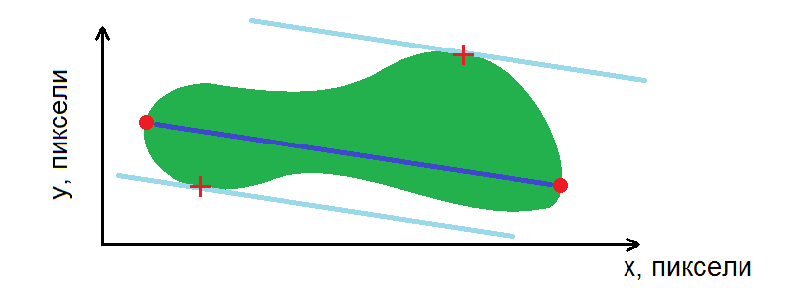
- Island image mask (green color). Red circles - the farthest pixels of the mask. Red crosses are two farthest points lying from the both side of the line, which connects the points indicated by red circles.

Anti-aliasing
Previously, it was shown that the more local maxima in the image, the more groups of pixels to which the image will be divided. This requires the results of the separation to process additionally. Fig.14 shows the AFM image of nanoislands on silicon surface while fig.15 - corresponding cross section drawn along blue line.
In addition to the maximum corresponding to the island (the green point in Fig.15a), local maxima are seen which do not correspond to the island (the red dots in Fig.15a). Obviously, in this case the substrate will be divided into a large number of groups of pixels. This negatively affects the processing speed of the image and increases the amount of memory allocated to processing. Fig.15b shows an example of smoothing, reducing the number of local maxima.
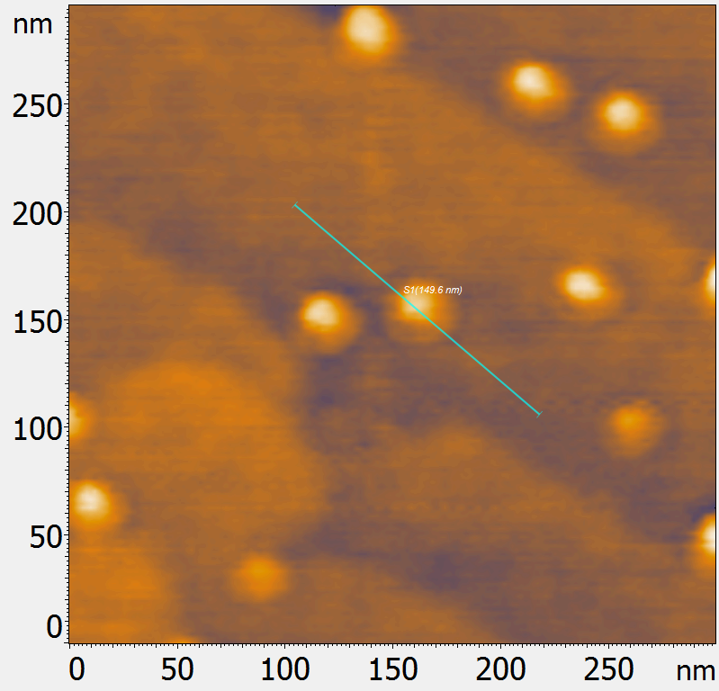
- AFM image of nanoislands on silicon Si(111).
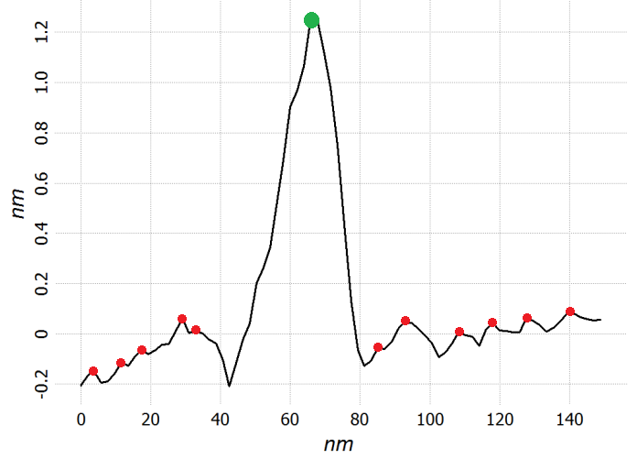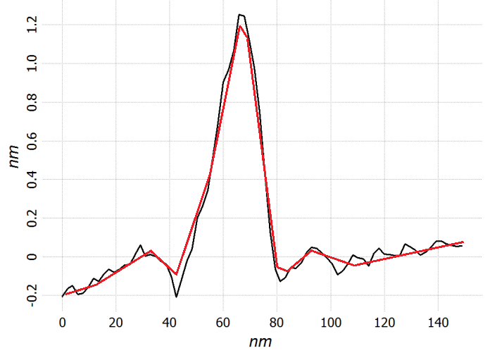
- Vertical section of the island in Fig.14 along the straight line. (a) – green point indicate the top of the island, red points – satellite local maxima; (b) An example of smoothing is shown by a red line, which makes it possible to reduce the number of local maxima.
An original approach to solving the problem of image smoothing was developed. First, on the basis of the image being smoothed, four images are constructed, then each of the constructed images is smoothed, interpolation is performed and a new image is constructed, as the average between the resulting images. Let's consider each stage in detail.
First, the image is divided into segments with a width of one pixel (each segment is indexed so that it is possible to build a smoothed image). The division is carried out in two directions: along the Ox axis and along the Oy axis. The length of each segments is equal to the size of the image in x and y direction, correspondingly. Then two child segments are built on the basis of each segment. Call a parent segment as "A". Then the segments constructed on the basis of the segment "A" are called "B1" and "B2". Consider the pixel of the segment "A" with the index i and apply the following rules to it:
- If the pixel i is on the boundary of a segment, then it is copied (the height and position is transferred) to the segments "B1" and "B2";
- If the height of the pixels i-1 and i+1 of the segment "A" is less than the height of the pixel i, then the pixel i is moved into the segment "B1" (and the corresponding place in the section "B2" remains empty);
- If the height of the pixels i-1 and i+1 of the segment "A" is greater than the height of the pixel i, then the pixel i is moved into the segment "B2" (and the corresponding place in the segment "B1" remains empty);
- In other cases, pixel i is copied into the segments "B1" and "B2".
The selection of the segment into which the pixel is copied is illustrated in Fig.16. Thus, four groups of segments are obtained from which four images can be constructed.
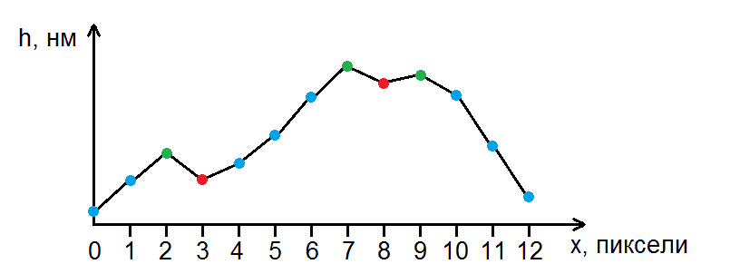
- A parent segment "A", on the basis of which child segments "B1" and "B2" are constructed. Green pixels are moved (the height and position is transferred) to the segment "B1". Red pixels are moved into the "B2" segment. Blue pixels are copied in both "B1" and "B2".
Consider the process of smoothing. The user selects a method for determining the height of pixels in each segment. Any method suitable for smoothing graphs, for example, a median filter, can be used. However, empty pixels are not taken into account. After the segments are smoothed, interpolation is performed to find the heights of the missing pixels. In this case, you can quickly interpolate by using the method of least squares (LS). For interpolation we use polynomials of the second degree like:
$h_{j}=aj^{2}+bj+c$ (6)
where h_{j} is the height of the pixel with the index j (nm); a, b, c – constants (nm).
Suppose you need to determine the height of the missing pixel with index i. Let's take four pixels with indices j₁, j₂, j₃ and j₄ for calculation by LS method, so: j₁ < j₂; j₂ < i; i < j₃ and j₃ < j₄. That is, we get a set of four pixels, two of which are to the left of pixel i, and the other two are to the right (in the special case, when only one pixel is to the left of pixel i, three will be taken to the right, and vice versa, if only one pixel is to the right of pixel i). The coefficients a, b, c can be found by solving the system of linear equations:
$\left\{\begin{aligned}a\sum_{k=1}^{4}{j_{k}^{2}}+b\sum_{k=1}^{4}{j_{k}}+4c=\sum_{k=1}^{4}{h_{k}} \\ a\sum_{k=1}^{4}{j_{k}^{3}}+b\sum_{k=1}^{4}{j_{k}^{2}}+c\sum_{k=1}^{4}{j_{k}}=\sum_{k=1}^{4}{h_{k}j_{k}} \\ a\sum_{k=1}^{4}{j_{k}^{4}}+b\sum_{k=1}^{4}{j_{k}^{3}}+c\sum_{k=1}^{4}{j_{k}^{2}}=\sum_{k=1}^{4}{h_{k}j_{k}^{2}}\end{aligned}\right.$ (7)
After that, calculate the height of the pixel i by the equation (6). The composition of the image from each group of segments can be formed when all segments are smoothed and interpolated (for the reason the indexing of segments was carried out in the beginning). The resulting images are numbered as 1, 2, 3, 4. Then find the height of pixels of the fifth image (which is the average between them) as follows:
$h_{ij}^{5}= \frac{1}{4}\sum_{k=1}^{4}{h_{ij}^{k}}$ (8)
where $h_{ij}^{k}$ - height of the pixel with coordinates (i; j) of the image with the index k (nm); i, j are running indices varying within [0; n_{x}] and [0; n_{y}], respectively (n_{x} and n_{y} are the image dimensions along the Ox and Oy axes).

Conclusions
Based on the algorithm described above, a software module was written that was tested on SPM images of islands, SPM images of "stuck" islands [11]. The program showed its operability and reliability of the received data on the topographic parameters of objects (size, concentration, relative position and uniformity). The main advantages are: good accuracy (error not more than 10%); relatively high speed of calculation; high degree of universality (the quality of calculations depends little on the nature of the structure being processed, images can be processed both with separately located objects, and complex mesh structures); simplicity of program settings.
With all the diversity of software solutions, it was assured that the described GA module successfully copes with all the tasks posed, regardless of the structure of the surface being processed. The developed method is simple enough, but at the same time, it is accurate and reliable.

References
- Alekseev, A. M. Buzin, A.I. Methods of SPM studies of polymers [Electronic resource]: Publications: Research methods - Access mode: http://www.ntmdt.ru/spm-notes/view/spm-for-polymers-investigations
- Protopopova, AD Molecular resolution with the help of SPM - we do it beautifully [Electronic resource]: Publications: Research methods - Access mode: http://www.nanometer.ru/2012/02/29/stm_270178.html
- Mironov, VL Fundamentals of Scanning Probe Microscopy, Nizhny Novgorod: Institute for Physics of Microstructures, Russian Academy of Sciences, 2004. - 114 p.
- Funami,T. Atomic force microscopy imaging of food polysaccharides. Food Science Technology Research, 2010, 16, pp. 1–12.
- Sokolova, E.A. Chusovitin, E.A. Barabanova, A.O. Balagan, S.A. Galkin, N.G. Yermak, I.M. Atomic force microscopy imaging of carrageenans from red algae. Carbohydrate Polimers, 93 (2013), pp. 458–465.
- Klapetek, P. Nečas, D. Anderson C. User guide Gwyddion [Electronic resource]: Documentation for the program: - Access mode:http://gwyddion.net/documentation/user-guide-ru/grain-analysis.html
- NT-MDT: Image Analysis P9. Image processing module. User's Guide [Electronic resource]: Documentation for the program: - Access mode: http://www.ntmdt.ru/data/media/files/manuals/Russian/ia_p9_rus.pdf
- The scanning probe image processor SPIPTM: User’s and reference guide version 4.8. – Denmark, Hørsholm: Image metrology, 2008. – 403 с.
- FemtoScan Wiki: Software FemtoScan Online [Electronic resource]: User manual: - Access mode: http://www.femtoscanonline.com/wiki/ru
- Shinya Ikeda, Victor J. Morris, Katsuyoshi Nishinari, Microstructure of Aggregated and Nonaggregated K-Carrageenan Helices Visualized by Atomic Force Microscopy. Biomacromolecules, 2001, 2, pp. 1331 – 1337.
- Dmitry L. Goroshko, Evgeniy A. Chusovitin, Igor M. Chernev, Alexander V. Shevlyagin, Konstantin N. Galkin, and Nikolay G. Galkin Solid phase epitaxy formation of silicon-gasb based heterostructures JJAP Conf. Proc. 2017, in press.

