Metrological performance of integrated waveguide-based SPR refractometer: eigenmode expansion perspective

Anton V. Dyshlyuk*^{a,b}, Oleg B. Vitrikª, Yuri N. Kulchinª
ªInstitute of Automation and Control Processes FEB RAS, 5, Radio Str., Vladivostok, Russia; ^{b}Vladivostok State University of Economics and Service, 41, Gogolya St., Vladivostok, 690014.

Abstract
The waveguide-based SPR refractometer is studied using state-of-the-art photonic simulation software based on eigenmode expansion method. Two distinct coupling regimes between the waveguide mode and surface plasmon mode are identified. Operating the refractometer in different spectral ranges to measure different values of the ambient refractive index is considered and its metrological performance under different modes of operation is assessed.

Keywords: Surface plasmon resonance, SPR, biosensing, waveguide-based SPR-refractometer.

INTRODUCTION
Refractometric sensors based on surface plasmon resonance (SPR) represent a promising direction in the development of modern biosensing [1-6]. Sensors of this type use resonant excitation of surface plasmon polariton waves (coupled oscillations of the electron density and the electromagnetic fields generated at the interface between metal and dielectric), for highly accurate measurement of the refractive index near the boundary. The most common scheme for constructing an SPR-refractometer is the so-called Kretschmann configuration , in which surface plasmons are excited by a beam of light incident from within the prism, on its face, coated with a thin layer of metal, at an angle exceeding the angle of total internal reflection. When the surface plasmon resonance condition is satisfied, the total internal reflection is violated and the energy of the incident beam is transferred to the surface plasmons, which leads to the formation of a resonant dip in the angular or frequency spectrum of the reflected light, whose position strongly depends on the refractive index (RI) of the medium near the metal film. To use such a refractometer as a bio- or chemosensor, a layer of ligand molecules-receptors capable of reacting with a certain type of analyte molecules is deposited onto the surface of the metal film .The association reaction between the ligand and analyte leads to a local change in the refractive index near the metal film and can be detected from the displacement of the resonant dip in the spectrum of the detected signal.
The Kretschmann scheme is well established and is widely used in laboratory biochemical research, but it is not well-suited for the development of compact, portable and inexpensive biosensor devices, including disposable sensors and sensors for point-of-care usage. Therefore, researchers pay increasing attention to waveguide-based SPR-refractometers in which plasmon-polariton waves are excited by radiation propagating along dielectric waveguides [7-9]. Sensors of this type, in contrast to the Kretschmann configuration, provide such possibilities as miniaturization and integration of sensing devices with fiber and integrated optics elements, carrying out measurements in hard-to-reach locations, and also potential reduction of the cost of SPR-based bio- and chemosensing systems [7-9].
In the present work, we perform numerical simulation of the waveguide-based SPR-refractometer using state-of-the-art photonic simulation software based on eigenmode expansion method to gain deeper insight into the operation of such refractometers and to optimize their metrological performance.

* anton_dys@iacp.dvo.ru, phone +7 4232 320624; fax +7 4232 310452; www.iacp.dvo.ru

Object and methodology of the study
The SPR-refractometer under study consists of three sections: 1, 3 - input and output sections of the waveguide without a metal film, 2 - sensing metallized section of length L (Fig.1). Parameters of the waveguide (thickness d₁ , RI n₁) are chosen so that it operates in a single-mode regime. A metal film supporting plasmon polariton modes (thickness d₃ ) is in contact with an external medium whose refractive index (n₃) is to be measured. Silver was chosen as the material of the metal film, and the data on its complex-valued permittivity are taken from the reference book [10]. To ensure the possibility of excitation of plasmon-polariton waves in a metal film, the direction of the electric field polarization of guided light is chosen in the plane of Fig. 1.

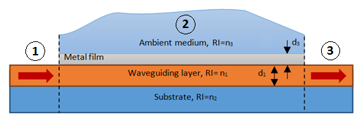
Figure 1. Schematic representation of the SPR-refractometer under study: 1-input section, 2-sensitive area, 3-output section.
The guided light in sections 1 and 3, thus, is described simply by a single fundamental mode, and two alternative approaches can be identified for the analysis of the propagation of light in section 2. In the first case, the guided radiation is represented as a sum of two hybrid modes of the entire multilayer waveguiding structure. In the second approach, the guided radiation consists of the waveguide and plasmon modes, considered separately, and their interaction arising when their propagation constants become close to one another, as described by the coupled mode theory, leads to their amplitudes becoming functions of the distance along the waveguide [11]. The first approach is more convenient for carrying out calculations and is used in this article for numerical modeling, and the second is physically more intuitive and is used to interpret numerical results.
In this work, numerical modeling was carried out using commercial photonics simulation software Lumerical Mode SolutionsTM (MS). It was used to calculate profiles and propagation constants of the modes of each of the three sections, including the hybrid modes of section 2, the amplitudes of the modes excited at the boundaries between the sections, the distribution of guided light field in section 2, and the transmission of the entire structure in the form of a ratio of the powers of the waveguide modes in sections 3 and 1.To simplify calculations, we chose the two-dimensional geometry of the problem corresponding to an idealized planar waveguide, but the results obtained can easily be generalized to the case of a similar integrated waveguide structure of rectangular cross section.
The materials and geometric parameters of the waveguiding structure are chosen in such a way that the phase-matching condition is fulfilled at a certain resonant wavelength.

Research results
From the practical point of view, it is reasonable to build waveguide-based SPR-refractometer using the most common materials, so we chose SiO₂ (n₂ ~ 1.45) as the substrate material and PMMA (n₁ ~ 1.49) as the material of the waveguiding layer. In this case, as shown by numerical calculations, at a thickness of the waveguide layer d₁ = 1.5 μm, film thickness d₃ = 60 nm, and refractive index of the external medium n₃ = 1.4, the dispersion dependences of the separately considered surface plasmon mode (the mode of the metal film contacting on one side with a semi-infinite external environment, and on the other side - with a semi-infinite dielectric with a refractive index n₁) and the waveguide mode (WM) (mode of the waveguiding layer bordering on one side to the semi-infinite substrate, and the other side - to the semi-infinite metal) intersect in the near infrared range (Fig. 2a). In the vicinity of the intersection wavelength, under the condition of a sufficiently high coupling coefficient between these modes, pronounced losses of the guided radiation can occur in the metallized region due to the effective transfer of the energy of the fundamental mode to the plasmon wave.
The presence of such losses is confirmed by the calculation of effective index spectra, modal losses spectra and profiles of the modes of the entire multilayer waveguiding structure of section 2 (fig. 2). As can be seen from the inserts 1 and 2, near the resonant wavelength, the profiles of both these modes contain elements of both the waveguide and plasmon modes, considered separately, so that they can be regarded as a result of hybridization of the latter modes. Since the profiles of both hybrid modes are close to each other, they are excited by the mode of section 1 with approximately equal efficiency, and their losses, which at the given wavelength are also equal and reach ~ 1700 dB/cm, lead to the attenuation of guided light power by more than 80 dB if the length of the metallized section is chosen to be e.g. as small as L = 0.5 mm. Off the resonant wavelength, as can be seen from the inserts 3 and 4, the profiles of the modes of section 2 are quite different, and only the low loss mode has a pronounced maximum in the waveguide layer region and is therefore effectively excited by the mode of section 1. There is no, therefore, strong attenuation of guided light in the metallized section at this wavelength. Thus, a pronounced dip appears in the transmission spectrum of the refractometer at the resonant wavelength (Fig. 2c).
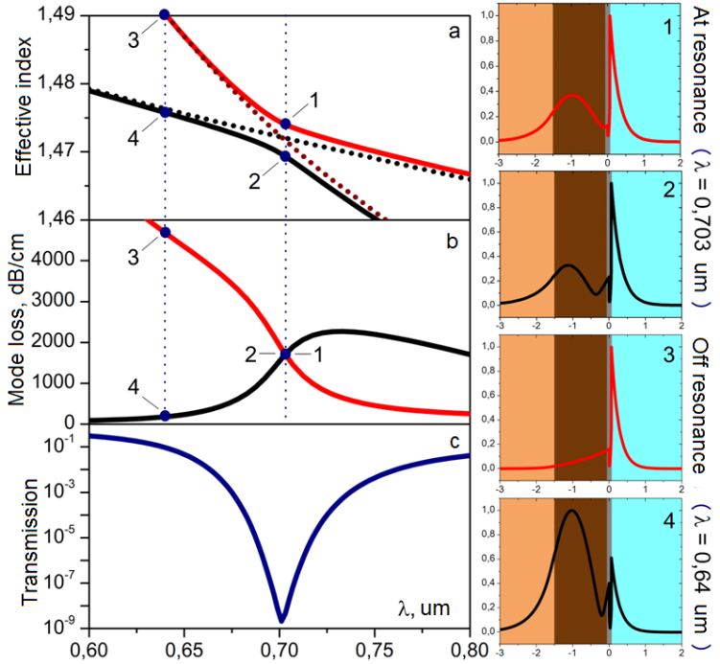
Figure 2. The results of the calculation of the effective index (a) and loss (b) spectra of the hybrid modes of section 2, as well as the transmission spectrum of the SPR-refractometer (c) at n ₃ = 1.4, d ₃ = 60 nm.Shown with dotted lines in (a) are the dispersion curves of the separately considered waveguide and surface plasmon modes. The insets on the right show the profiles of the hybrid modes of section 2 at the resonant (inserts 1 and 2) and a non-resonant (inserts 3 and 4) wavelength.
Calculations of the dispersion dependences of the hybrid modes of section 2 at different thicknesses of the metal film show that the formation of the resonant dip can occur in two different scenarios. If the film thickness is 68 nm or less there is an anticrossing in the effective index spectra and crossing in the loss spectra of hybrid modes as illustrated in Fig. 2 (d₃ = 60 nm) and Fig. 3 (d₃ = 45, 68 nm). At a film thickness of 69 nm and more - on the contrary, the effective index spectra intersect, while the loss spectra exhibit anticrossing behavior (Fig. 3, d₃ = 69, 74 nm).
These two scenarios correspond to two different coupling regimes at the resonant wavelength between the separately considered waveguide and surface plasmon modes. The first regime can be conveniently referred to as "strong coupling" , since in this case the coupled modes exchange power as they propagate along the waveguide . This is illustrated with the electric field amplitude distribution of guided light in section 2 shown in Fig. 3 for the case when the film thickness is 45 nm .From the point of view of the entire multilayer structure of section 2, this exchange corresponds to interference beating of hybrid modes with different propagation constants. Note that the exchange period increases as the coupling becomes weaker .Thus, at a film thickness of 68 nm, despite the strong coupling scenario, the difference in the effective indexes of hybrid modes of region 2 is so small that the period of the beats is greater than the characteristic attenuation length of guided light, and the exchange of power between the coupled modes becomes hardly seen (Figure 3, d ₃ = 68 nm).
The second hybridization scenario can be associated with the weak coupling regime between the waveguide and surface plasmon modes, in which periodic power exchange between them does not occur. In terms of the modes of section 2, this corresponds to a situation in which interference beats between hybrid modes at the resonance wavelength do not arise because of their propagation constants being equal.
Calculations show that the coupling regime between the waveguide and plasmon modes depends mainly on the value of the coupling coefficient, which is determined by the degree of overlap of their profiles .In this scheme, the coupling coefficient is primarily determined by the thickness of the metal film d ₃ - with increasing film thickness, the mode profiles overlap less, which leads to a weaker coupling. If the coupling becomes too weak (for example, at d₃ = 74 nm, Fig. 3), both the profiles and losses of the corresponding hybrid modes at the resonant wavelength are significantly different (inserts 1 and 2 in Fig.3) The hybrid mode with smaller losses is closer in its profile to the waveguide mode, and it is, therefore, excited by the mode of section 1 with the greatest efficiency. The amplitude of the mode with higher losses is much smaller, and it has little effect on the resulting transmission of the entire structure. As a result, as can be seen from Fig. 3, the depth of the resonant dip in the transmission spectrum decreases noticeably.
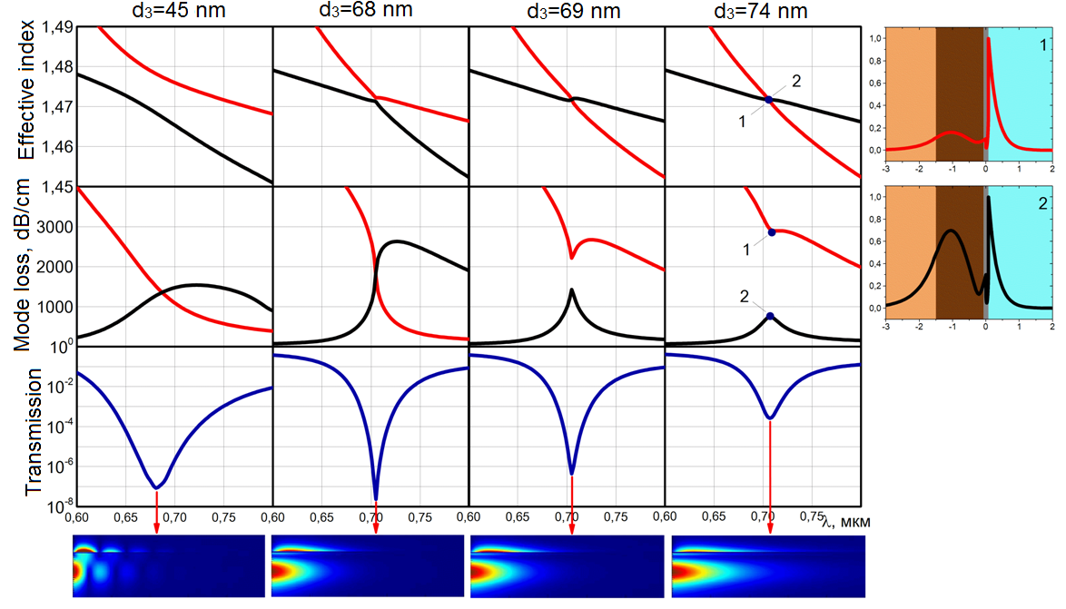
Figure 3. The results of calculation of effective index spectra, mode loss spectra and transmission spectra of the SPR-refractometer for various thicknesses of the metal film. The inserts below show the calculated distributions of the electric field amplitude of guided light in section 2 at the resonant wavelength for different thicknesses of the metal film.The insets on the right show the profiles of the hybrid modes of section 2 at the resonant wavelength at d ₃ = 74 nm (L = 500 μm, n ₃ = 1.4).
On the other hand, if the coupling becomes too strong, for example, at d₃ = 45 nm, the spectral range where it is realized is substantially broadened, which leads to the corresponding broadening of the resonant dip (Fig. 3, d₃ = 45 nm).
Thus, from the point of view of obtaining the sharpest resonant dip, the optimal case is obviously that of critical coupling just at the boundary between the strong and weak coupling regimes (Fig. 3, d₃ = 68, 69 nm). From these considerations, it is reasonable to choose the optimal film thickness for a given value of the measured refractive index.
However, when n₃ changes, the resonance wavelength is shifted, which also leads to a change in the coupling coefficient between the waveguide and plasmon modes and, accordingly , to a change in the coupling regime. This is explained by the fact that for longer wavelengths, the profiles of both modes broaden and overlap with each other more effectively. In addition, calculations show that the losses of the surface plasmon mode also affect the coupling regime. This is due to the fact that these losses correspond to the degree of mismatch of the propagation constants of the coupled modes, which have the same real parts at the resonant wavelength and differ only in imaginary parts. The lower losses lead to more efficient coupling and therefore, as the resonant wavelength increases, the coupling becomes stronger, also because of a decrease in the losses of the surface plasmon mode.
Fig. 4 shows the results of calculating the transmission spectra of the SPR-refractometer at d₃ = 68 nm, n₃ = 1.395-1.41. As can be seen, with an increase in the resonance wavelength for larger n₃, there is, first, a gradual increase in the depth of the dip in the weak coupling regime as the coupling strength grows. Secondly, starting with n₃ = 1.4, when the coupling regime switches to the strong coupling, small variations in the depth of the resonance dip are observed as n3 increases further .They arise due to changing transmission losses at the boundary between sections 2 and 3 because of a decrease in the period of power exchange between the waveguide and surface plasmon modes as the coupling becomes stronger with increasing λ_{SPR} . The decrease in the power exchange period between the coupled modes corresponds to an increase in the effective index difference of the hybrid modes of section 2 at the resonant wavelength (as shown by the arrows in the insets to Fig .4). Third, with a further increase in n₃, the resonance dip is broadened because the coupling becomes too strong. These circumstances determine the measuring range of the refractive index n₃, which can be varied by choosing a different value of the thickness of the metal film.
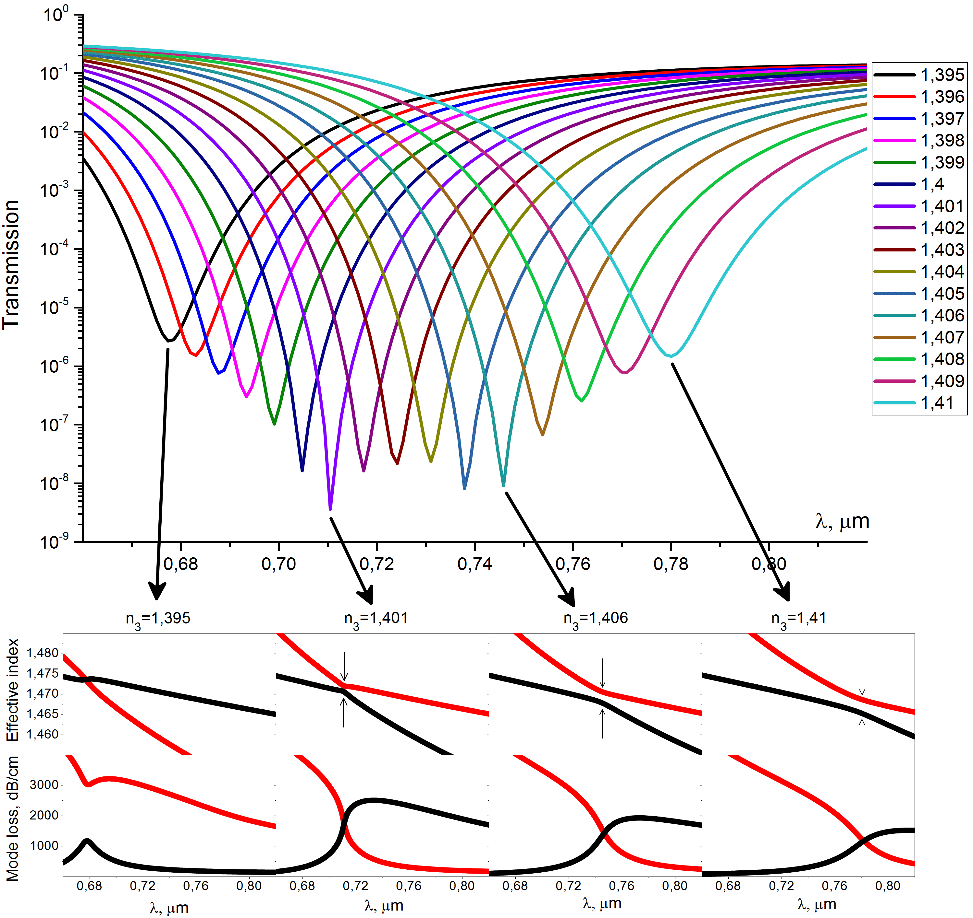
Figure 4. The calculated transmission spectra of the SPR-refractometer for different values ​​of the refractive index of the ambient medium. The inserts below show the effective index and modal loss spectra of the hybrid modes of section 2 at different refractive indices of the ambient medium (L = 500 μm, n ₃ = 1.395-1.41).
From the analysis of Fig. 4, we can conclude that the spectral sensitivity in this case is ~ 6800 nm / refractive index unit (RIU) and the minimum half-width of the resonance dip (when n₃ = 1.404) on a logarithmic scale (full width at square root of the minimum value (FWSRM)) ~ 25 nm, which gives FOM ~ 270, where FOM - figure-of-merit, defined as the ratio of the spectral sensitivity to the half-width of the dip. If the refractive index of the medium under study changes in the layer much thicker than the penetration depth of the surface plasmon mode into the given medium, the resolution of the refractometric measurements is inversely proportional to the value of FOM [4]. However, it is also shown in [4] that if the thickness of the layer in which the refractive index n₃ varies is significantly smaller than the penetration depth mentioned above, the metrological performance of the SPR refractometer should be characterized by its local sensitivity given by:
where $S_{RI}=\frac{{dλ}_{spr}}{dn_{3}}$ spectral sensitivity, d_{lig} - thickness of the sensing layer, d_{sp} - 1/e depth of penetration of the surface plasmon mode intensity into the ambient medium.
The latter situation arises if the SPR-refractometer is used as a bio- or chemosensor, in which the thickness of the receptor molecules layer is much less than the depth of penetration of the plasmon mode into the external medium. In view of the foregoing, we will assume that the resolution of refractometric measurements in a thin sensing layer
$σ_{loc}∝LRI=\frac{d_{sp}}{FOM}$, where LRI is the local resolution index (the smallest LRI corresponds to the best metrological performance if the ambient refractive index is to be measured in a thin sensing layer).
The depth of penetration of the surface plasmon mode into the external medium in the vicinity of the wavelength λ = 700 nm is ~ 120 nm (the inset to Fig. 5), which gives for the results presented in Fig. 4, FOM ≅ 270 and LRI ≅ 0.44.
It should also be noted that the considered configuration of the SPR-refractometer can also be used to measure other values ​​of the refractive index of the external medium - both greater and less than 1.4. For example, for n₃ ~ 1.35, the phase matching condition between the plasmon and waveguide modes is satisfied near the wavelength λ ~ 0.55 μm (Fig. 5a). In this case, the optimum thickness of the silver film is 58 nm. To preserve the single-mode operation of the waveguiding layer at this wavelength, its thickness should be reduced to 1 μm.
The losses of the surface plasmon mode at the given wavelength, as can be seen from the inset to Fig. 5 are several times larger than in the vicinity of λ = 0.7 μm, but the width of the resonance dip is lower than for n ₃ ~ 1.4 because of the significantly larger intersection angle of the dispersion dependences of the waveguide and plasmon modes (Fig. 5a): FWSRM ~ 16 nm (at n₃ ~ 1.35). For the same reason, in spite of the fact that the physical sensitivity of the plasmon mode to n ₃ tends to increase for shorter wavelengths [4], the spectral sensitivity in this case is more than two times lower than for n₃ ~ 1,4 : ~ 2500 nm / RIU.Thus, FOM ≅ 155, which is almost twice lower than in the previous case. The depth of penetration of the plasmon mode into the external medium , however, near λ = 550 nm is ~70 nm (the inset to Fig. 5) which is much less than at λ ~ 700 nm and, so from the point of view of measuring local RI variations in a thin layer there is practically no distinction from the previous case: LRI ≅ 0.45.
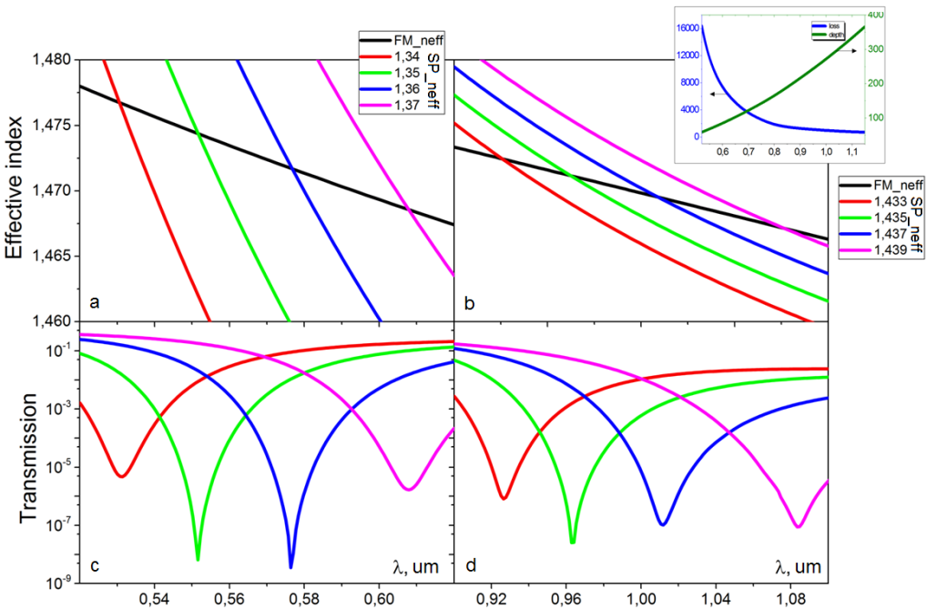
Figure 5. The calculated dispersion dependences (a, b) of the fundamental mode (the black curve) and the plasmon mode (color curves) for different refractive indices n ₃ , as well as the calculated transmission spectra of the SPR-refractometer at n ₃ ~ 1.35 (s) (L = 200 μm, d ₃ = 58 nm, d ₁ = 1 μm) and at n ₃ ~ 1.435 (d) (L = 1300 μm, d ₃ = 75 nm, d ₁ = 2.5 μm). The inset in the upper right-hand corner shows the surface plasmon mode losses, dB / cm (blue curve) and the depth of its penetration into the external medium, μm (green curve) vs. wavelength.
At n₃ ~ 1.435, the phase matching between the waveguide and surface plasmon modes occurs near the wavelength λ = 1 μm (Fig. 5b). The optimum film thickness in this case is 75 nm, and the thickness of the waveguiding layer is 2.5 μm. The main peculiarity of this spectral range is the substantially smaller angle of intersection of the dispersion curves of the waveguide and plasmon modes than in both previous cases. This leads, first, to a significant increase in the spectral sensitivity : ~ 26,000 nm / RIU and, secondly, to the corresponding broadening of the resonance dip. The latter feature, however, is partially compensated for by low losses of the plasmon mode at λ ~ 1 μm, which results in FWSRM 44 nm (at n₃ ~ 1.435) .Thus, in terms of sensitivity and width of the dip, we obtain a noticeable advantage in this case: FOM ≅ 590. However, from the point of view of measurements of local RI variations in a thin layer, there is practically no difference from the two previous cases: LRI 0.46 due to the large depth of penetration of the plasmon mode field into the external medium at this wavelength (d_{sp} ~ 270 nm, inset to Fig.5).

CONCLUSIONS
Thus, using the eigenmode expansion method and the Lumerical photonics simulation software we have numerically studied the waveguide-based SPR-refractometer. It is shown that, depending on the thickness of the metal film, the formation of a resonant dip in the transmission spectrum of the refractometer can proceed according to two different scenarios corresponding to the strong and weak coupling regimes between the separately considered waveguide and surface plasmon modes. From the point of view of obtaining the sharpest resonant dip, the optimal case is that of critical coupling just near the boundary between the strong and weak coupling regimes. It is shown that the SPR-refractometer under study can be used to measure different values ​​of the refractive index of the ambient medium ranging from ~ 1.34 to ~ 1.44 by properly selecting the working spectral range. The choice of a longer wavelength spectral range makes it possible to obtain approximately an order of magnitude higher spectral sensitivity, in comparison with the sensitivity in the short-wavelength spectral range due to the much smaller intersection angle of the dispersion dependences of the waveguide and surface plasmon modes. The latter circumstance also leads to a broader resonant dip, but due to the decrease in the losses of the plasmon mode at longer wavelengths, a significant advantage is achieved in terms of the figure-of-merit parameter, defined as the ratio of the spectral sensitivity to the half-width of the dip .On the other hand, the resolution of RI measurements in a thin sensitive layer depends only weakly on the choice of the spectral range, since a higher value of FOM comes at a cost of larger penetration depth of the plasmon mode into the ambient medium, which impairs the local resolution.

ACKNOWLEDGEMENTS
The work has been partially supported by the Russian Foundation for Basic Research (grant #16-32-00384), the «Far East» program of FEB RAS and FASO, and the ERA.Net Rus Plus program.

References
- Rasooly, A., Herold, K. E., (ed.), [Biosensors and biodetection], Humana Press, (2009).
- Ligler, F. S., Taitt, C. R., (ed.), "Optical biosensors: today and tomorrow," Elsevier, ( 2011).
- Baldini, F., et al., (ed.), "Optical chemical sensors," Springer Science & Business Media, Т. 224, (2006).
- Homola, J., "Surface Plasmon Resonance Based Sensors," Springer Series on Chemical Sensors and Biosensors ,Springer-Verlag, Berlin-Heidelberg-New York, (2006).
- Homola, J., “Surface plasmon resonance sensors for detection of chemical and biological species,” Chem. Rev., 108(2), 462–493 (2008).
- Guo, X., Biophoton, J., 5, 483–501 (2012).
- Leung, A., Shankar, P. M., Mutharasan, R., "A review of fiber-optic biosensors," Sensors and Actuators B: Chemical, Т. 125(2), 688-703 (2007).
- Caucheteur, C., Guo, T., Albert, J., "Review of plasmonic fiber optic biochemical sensors: improving the limit of detection," Analytical and bioanalytical chemistry, Т. 407(14), 3883-3897 (2015).
- Bosch, M. E., et al., "Recent development in optical fiber biosensors," Sensors, Т. 7(6), 797-859 (2007).
- Palik, E. D., [Handbook of optical constants of solids], Academic press, Т.3 (1998).
- Snyder, A. W., Love, J., [Optical waveguide theory], Springer Science & Business Media, (2012).

