Integration of Gamification into the Educational Process of Technical Specialties
Igor А. Belous (0000-0001-8519-4390)¹, Irina А. Pyatkova (0000-0002-5657-6282)^{1(*)}, Mikhail V. Kovyrnev (0000-0003-3658-9526) ¹, Mikhail V. Klyukman (0000-0002-0227-8765) ¹, and Dmitriy G. Soroka (0000-0001-6656-0682)¹
¹ Vladivostok State University of Economics and Service, Vladivostok, Russia
Igor.Belous@vvsu.ru, mellkiss1988@gmail.com, misha.kovyrnev@gmail.com, mihail.klyukman@vvsu.ru, dima.soroka.2024@gmail.com
Abstract. Currently, the human brain processes several tons of information per second. This factor applies both to everyday life and the process of studying at the university. The issue of concentration loss among students is becoming increasingly relevant. It has been called “clip thinking” (or “mosaic thinking) due to the growth of fast and short multimedia entertainment – clips. The primary task for the authors is to develop a curriculum that will not differ from the university standards in terms of the quality of content but will fundamentally differ in the method of presenting the material by integrating game elements to reduce the effect of routine in the study of technical literature. The authors describe three developed possible types of implementation of activity in the educational process within the framework of implementation in technical specialties – ”4 x 4," “Jacket,” and “Carousel.” Each type provides for several implementation scenarios. The research aims at comparing the effectiveness of “gamification” in comparison with “classical” methods of teaching the material. Identification of the effectiveness of new methods is carried out using a direct comparison of students’ grades of different years for similar education programs. The experiment has been conducted with the participation of second-year students of the BIK-18-01 group based on the classrooms of the federal state-owned publicly-funded institution of higher education “VSUES.” The work has resulted in an evident increase in the average academic performance of students who have enrolled in 2018 with 2017. There is a significant increase in students with an “excellent” grade and an increase in overall performance indicators according to the 100-point system, where 0 is the minimum score, and 100 is the maximum, from 76.14 to 84.2 points.
Keywords: Gamification ∙ Introduction ∙ Pedagogy ∙ Interaction ∙ Game ∙ Gamification ∙ Play-based learning

Introduction
In systematizing modern teaching methods, one can distinguish the following subcategories:
- Passive methods;
- Active methods;
- Interactive methods (Olesova & Afanasyeva, 2018).
Passive method – the interaction is rigidly divided into a “master” (teacher) and a “slave” (student). An excellent example of a “passive” teaching method can be a streaming lecture at a university or explaining a new topic by a teacher at school. The teacher lectures and the student writes it down. Slight interaction in the form of questions from students to the teacher and vice versa is allowed.
The active method provides for active interaction between the student and the teacher. For example, calling a student to the blackboard to solve a problem together or seminars at the university, when the teacher and students actively discuss the topic, they have passed and made presentations. Therefore, the teacher becomes a source of “traffic” in the audience, but the students themselves take an active part in creating an information field within the audience.
Interactive method. Interactive (“inter” means mutual, interactive – mutual act) implies having feedback and being in action and interacting. The primary feature of this method is a reversible approach to learning. If the teacher plays the primary role in the first version of interaction, and in the second one, a bias towards students is allowed, then the interactive method focuses entirely on students. In this format, students focus on intra-group interaction, and the primary information source is the students themselves. This approach is gaining more and more popularity because it allows students to concentrate on forming the ability to analyze and self-educate critically. As an example, one can cite social projects, research work in teams, or classes in the format of educational games (Levchenkova & Cherenkova, 2017).
Currently, the training methods listed above are successfully implemented using e-learning. This method is one of the varieties of training, the apparent difference of which is the emphasis on the use of information technologies and computers in the course of education. Due to the constant development of electronic computing devices and the ubiquitous spread of the Internet environment, the validity of the application of existing advantages is growing every day. Specifically, one of the advantages of e-learning is the possibility of learning remotely, an excellent indicator of engagement, accessibility, etc. (Belous & Chupalov, 2019).
The primary research goal is to develop, test, and evaluate the effectiveness of the mixed teaching method entitled “gamification.” “Gamification” is a system that will help, if successfully implemented, not only diversify but also radically change the educational process, making it easier to understand and more exciting and diverse. It includes effective methods of traditional forms of learning using e-learning and active/interactive methods. The research aims primarily at the introduction of the “gamification” method into a laboratory workshop, using the example of the discipline “General theory of communication,” built based on the NI ELVIS II Emona DATEx and NI Multisim software and hardware platforms, using the e-learning course of the same name, based on the e-learning system built on the university-wide Moodle platform.
The use of the Moodle e-learning system (ELS) as a platform for the placement of modernized, integrated teaching methods, educational and methodological materials will provide the following (Belous et al., 2019):
  - Minimizing the teacher’s labor costs for checking the completed works;
  - Transfering of the checking and evaluation system to the online mode with the help of tools for creating online tests;
  - Using the tools included in the ELS to provide educational and methodological material in a short time and receive feedback from students through a system of forums, video conferences, and comments on the completed work;
  - Centrally monitoring the progress of the entire cohort of students, monitoring the stages of work completion, and responding to deviations from the curriculum promptly.

Materials and Methods
First of all, the integration of active forms of learning, particularly gamification, with e-learning implies the effective use of classroom time and the flexibility of the educational process. The authors’ primary goal is to offer various solutions with which this process can be carried out.
The primary research tasks include improving students’ academic performance, increasing their involvement in the educational process, and increasing the concentration of students’ attention on the studied material.
In order to approach the solution of the issues described above, the authors have studied and analyzed the theoretical basis of scientific-methodical and psychological-pedagogical literature, for which the authors have referred to popular science journal articles, as well as the works of M. M. Olesova and S. R. Afanasyeva (2019) in the field of gamification, which have been further supported experimentally. The authors have compared the scores obtained between a group that has not integrated a new method of learning using gamification with a group whose educational process has introduced a new type of education for them, the results of which are shown below.
It is a well-known fact that students of recent generations differ significantly in the perception of information from the preceding generations (Dautov, Korochentseva Kadom & Hussin, 2019). The so-called “clip thinking,” due to widespread digitalization, implies the rapid absorption of information from the screen in the form of short messages, video or audio information, as well as the complete rejection of the so-called “longreads,” which implies texts which take a long time to read.
This feature of modern students leads to a conflict between “traditional” teaching methods and students’ peculiarities of information perception. First of all, this problem encapsulates a decrease in the interest to learn and the effectiveness of education since holding attention for a long time for complex literature full of compound terms and figures becomes almost impossible.
To solve the primary task of the paper, one needs to create scenarios that will fully reflect the essence of gamification. After analyzing the typical activities in the implementation of gamification in education, considering the technical direction of education, three possible types of implementation of activity in the educational process have formed within the framework of implementation in technical specialties “4 x 4,” “Carousel” and “Jacket.” Each type provides for several implementation scenarios. Furthermore, the authors present a detailed substantiation of why a particular implementation concept has been chosen in the description of each of them.
The first scenario proposes the following. The essence of “4 x 4” is to assemble a primary electrical circuit from four card parts. However, this process is complicated by various parallel tasks, the solution of which will allow one to perform the primary task. Since the authors’ installment involves implementation in technical specialties, most of which, in turn, include specific physical disciplines, the authors provide circuit schemes. They are being utilized in various branches of physics, and their memorization often perplexes students. The goal of “4 x 4” is to create associative thinking by comparing disparate parts and combining them into a single entity. To make it more comprehensible, the authors have chosen electrical circuits as an example of this concept implementation. The authors have developed two scenarios for implementing this type of mechanics.
The first scenario of the “4 x 4” type is called “Stickman.” This activity involves a complication in the form of a random distribution of parts of the scheme between different teams. Therefore, the share of the necessary elements can be on the cards of other teams, which provokes students to quickly analyze the obtained data, search for the necessary components of the scheme from other teams, and update the theoretical knowledge obtained in the shortest possible time. One can observe an example of completing the task in Fig. 1–2.
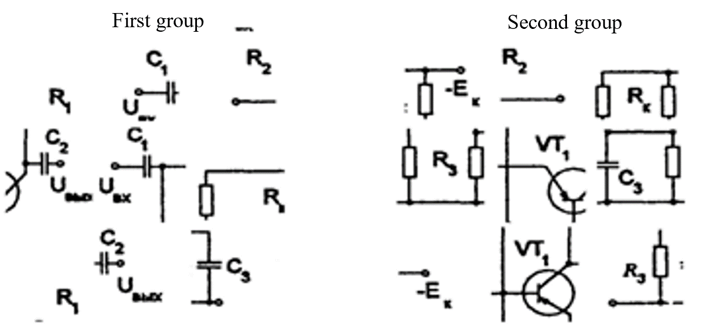
Fig. 1. The initial distribution of cards according to the “Stickman” scenario.
Source: Compiled by the authors.
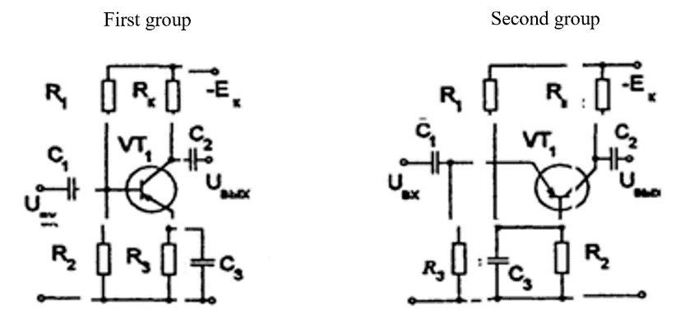
Fig. 2. The location of the cards after completing the task according to the “Stickman” scenario. Source: Compiled by the authors.
The second scenario is “Odd-man-out” – Fig. 3. As the name implies, one needs to isolate cards from the group of received elements that are not suitable for completing the task. The evaluation criterion may be a time limit, which is how quickly students can understand which elements are odd; thus, the remaining parts should be located.
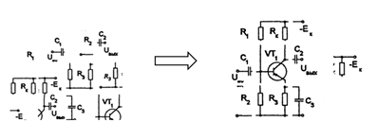
Fig. 3. The initial and final location of the cards when implementing the “Odd-man-out” scenario. Source: Compiled by the authors.
Undoubtedly, these two scenarios may vary, for instance, in the number of cards or the type of schemes on them. However, it is essential to understand that there is a minimum restriction since splitting the schemes into less than three parts will not make sense. In the current case with circuit schemes, the authors do not believe it is relevant to split them into more fragments since it will make it challenging to complete the task.
Another type of gamification is “Carousel.” Its primary direction is the group’s work at the stands, but it can be adapted to other tasks. Commonly, teachers use the division into groups for a visual example of the performance of work and simulate actual working conditions. Undoubtedly, it happens not only in technical universities. However, in the description of this method, the authors will focus on technical stands. The authors imply, for instance, demonstration stands for working with various devices and schemes. Working with them, in any case, implies the distribution of members of one team into isolated roles. It means that each student is responsible for a specific type of work (Fig. 4).

Fig. 4. Performing laboratory work utilizing distribution of roles.
Source: Compiled by the authors.
Even if no one distributes roles among students, they will choose precisely what they favor. Nevertheless, the correct division of labor is significant for more effective work; therefore, the authors will resort to it (Fig. 5). The “Carousel” concept is wholly built on the fact that no team member is deprived and can try themselves in every role, participate fully in the process, and understand how each work stage is arranged. The concept implies the same roles for each scenario as follows:
- A student sitting at the stand and performing principal actions required for laboratory work;
- A student filling in data in spreadsheets and taking screenshots necessary for the report;
- A student preparing the report.
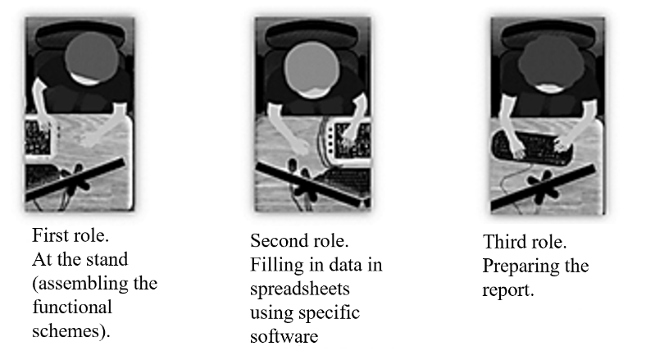
Fig. 5. Roles in the “Carousel” team. Source: Compiled by the authors.
The authors consider the roles in the “Carousel” team for only three people, taking into account that, if necessary, one can increase the number of people up to five. One can also assume that the number of participants may be reduced to two people, which will entail certain inconveniences. Therefore, a team of three people is the most optimal. As an example for a more evident analysis of the location of students in groups, the VSUES office for laboratory work has been selected and sketched (Fig. 6). Two concepts of the development scenario for the “Carousel” have been developed: “Intra-team carousel” and “Control carousel.”
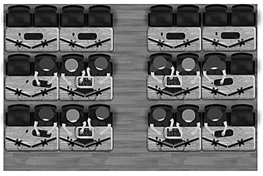
Fig. 6. An office for the “Carousel.” Source: Compiled by the authors.
The essence of the first concept of “Intra-team carousel” is to divide students into groups and assign each their own role according to the sketch. Next, the laboratory work is performed directly, during which the roles should be changed clockwise. In other words, students on the same team change places and, accordingly, roles clockwise. By virtue of these mechanics, students are involved in all stages of work on the task, which will also help them maintain clarity of thought while constantly switching the type of work – and this is a practical skill in life.
Additionally, as with implementing the first concept, students will have to change places in the “Control Carousel” concept, but this time everything is somewhat more complicated. Gamification participants are also invited to distribute into roles within their team and perform laboratory work. The teacher sets a timer for a specific time, during which participants must complete one or another part of the task. To elaborate, at a certain point in the text, they will observe a point concerning changing places, after which, as well as after the timer expires, they will switch places with people with the same role in the neighboring team. Then they will check the work of their “colleague” and return to their place. Therefore, in this concept, one adds a timer that will keep students in some control, as well as the ability to check each other. These two points are also critical in real life of students, the need to meet the deadlines set by order of work, as well as the ability to understand someone else’s work, observe shortcomings, and eliminate them to achieve a better result (Pyatkova, Klyukman & Belous, 2020).
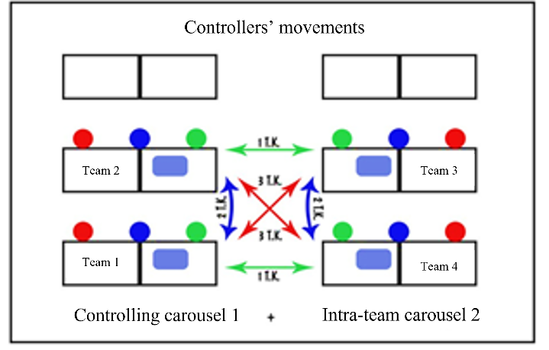
Fig. 7. The scheme for the “Intra-team carousel.” Source: Compiled by the authors.
The next – developed by a unique gamification scenario – is a scenario called “Jacket.” The primary goal of this scenario is to improve communication skills. It also aims at assimilating in-depth knowledge in stressful situations. The “Jacket” scenario helps students improve abstract thinking, memory and applying the acquired knowledge in practice. These skills are necessary for any group of specialties. However, the authors assume that participants will be able to navigate more easily in complex technical terms, setting themselves the task of remembering them and explaining them to another person. It contributes to better comprehensibility of the material. Two possible concepts are implemented for the “Jacket” – “Apprentice” and “Broken telephone.”
Both concepts have roles that need to be assigned before one starts working with them. Students are divided into several groups; in each, an assumed “Leader” is chosen (a person who will give commands); during gamification, they do not act by themselves; the rest are “Apprentices.”
In the first version of the “Apprentice” scenario, initially, there is a division into roles, then the “Leader” receives a task (the text version of which only they observe). Their task is to explain to their group precisely what they need to do in order to perform it correctly (as an example, the correct order of assembling the necessary scheme). They are deprived of the opportunity to observe what they are doing, so they must formulate their thought as transparently as possible employing terminology. The “Apprentice,” in turn, tries to perform tasks correctly. Since only the intra-team result is crucial, there may be a competitive effect.
Nevertheless, this opportunity should be provided by the teacher. In the end, the group joins back together, performs tasks, and works on errors. Fig. 8 provides a visual representation of the work.
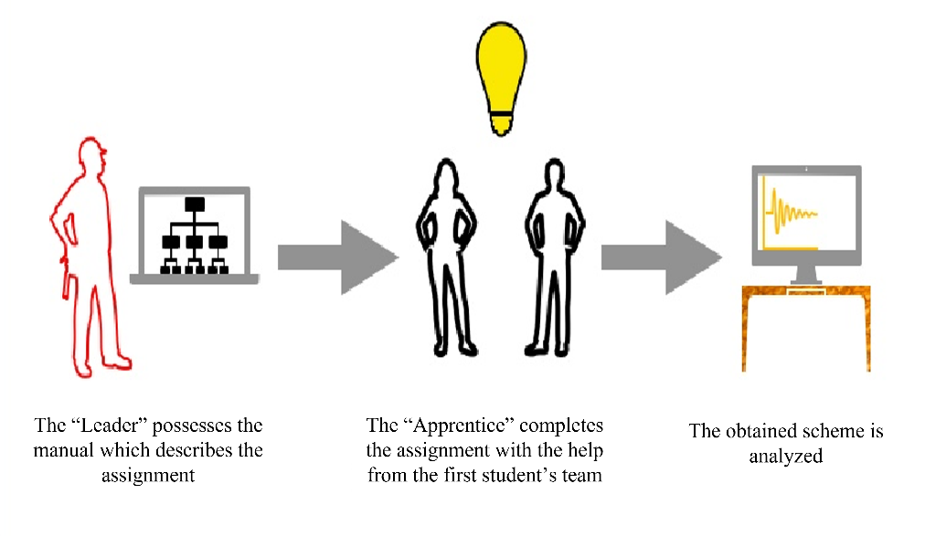
Fig. 8. “Apprentices.” Source: Compiled by the authors.
The “Broken telephone” concept implies roughly the same order. However, there are some “in-game” differences. If in the previous concept, the number of groups has not been specified (in other words, the “Apprentice” can be implemented for one group), then in this case, one needs an even number (at least two). In this concept, groups work on someone else’s result, the initial scheme is the same –teams are formed, and a “Leader” is selected in each team. Nonetheless, the execution of the work implies that the “Apprentice” tries to form (sketch) a task for another team, and then an exchange occurs. For example, they sketch electrical schemes and then exchange them. It is how the work is performed. If everything is correct, the group that submitted the task receives additional points (determined by the teacher), and their colleagues join back and perform it. If not correct – students should find mistakes and eliminate them. Fig. 9 demonstrates the scheme (Pyatkova et al., 2020).
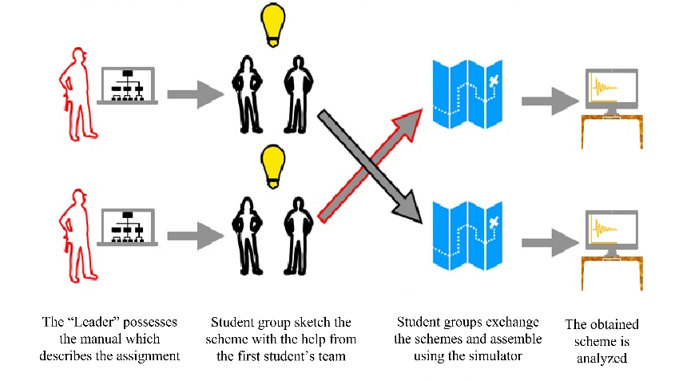
Fig. 9. “Broken telephone.” Source: Compiled by the authors.
The number of people can vary. The authors assume the optimal number of three. Nevertheless, if necessary, it can be a team of two people, but also, as with the previous scenario, the authors believe that it may not be very convenient. However, it is possible to implement if there are no alternative options. It also applies to the task. Its complexity should be comparable to the ability of the people participating in gamification. Too complex tasks can perplex them and make it difficult to obtain and verify their knowledge and create inconveniences.
Therefore, each student is involved in performing laboratory work, and their knowledge is used at all stages of the task, whether it is implementing a scheme, taking readings, or writing a report. This type of gamification allows students to learn how to quickly adapt to a new type of work, establish trusting relationships within the team, and work in a limited time frame.

Results
As has been mentioned above, the “Carousel” can adapt to types of tasks that differ from the practical ones. For example, one can take the “game of chance” scenario, which is closest to the traditional certification methods. The team obtains a random element of the scheme, and they should provide as much information about it as possible. For example, the first person gives the name and scope of the elements; the second describes the principle of operation and its characteristics; and the third – additional properties of the element that their colleagues have not listed.
After the development and adaptation of game mechanics, they have been tested on a control group. At the end of the course, the average score of the student in the group has been calculated, and a direct comparison has been made with the results of the BIK-17 group (Fig. 10), which studies the subject using the “classical method.” this comparison, for methodological reasons, cannot be carried out as a “pure scientific experiment.” Nevertheless, it will help trace some general trends according to the criterion of “academic performance.” The BIK-18 group and the discipline “Signalling theory” are selected as experimental groups with a digital training course in the Moodle digital educational environment. This discipline is impeccably suitable for experimenting with the introduction of gamification since this course provides a substantial amount of hours for laboratory and practical work.
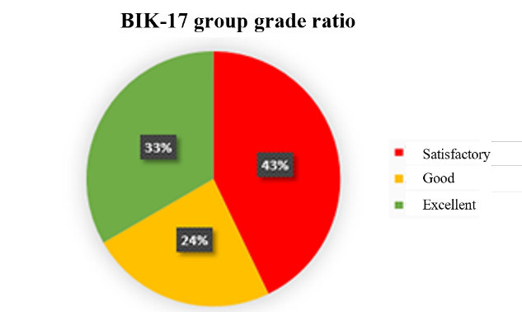
Fig. 10. Circle diagram of the ratio of the BIK-17 group students’ grades with an average grade of 76.16. Source: Compiled by the authors.
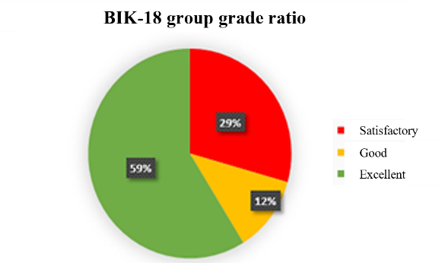
Fig. 11. Circle diagram of the ratio of the BIK-17 group students’ grades with an average grade of 84.2. Source: Compiled by the authors.
Table 1. A survey after introducing gamification in the educational process.
Number of people participating in the survey | The material is mastered satisfactorily | The material is mastered well | The material is mastered perfectly
17 | 25% | 65% | 10%
14 | 31% | 63% | 6%
19 | 27% | 60% | 13%
Source: Compiled by the authors.
Table 2. A survey before introducing gamification in the educational process.
Number of people participating in the survey | The material is mastered satisfactorily | The material is mastered well | The material is mastered perfectly
17 | 17% | 71% | 12%
14 | 20% | 72% | 8%
19 | 15% | 74% | 11%
Source: Compiled by the authors.
One can notice that after the introduction of gamification, the average number of students began to master the material better than before the introduction. This factor directly indicates the effectiveness of the performance criterion and indirectly indicates the interest of students.
The result of the survey is a significant increase in students with an “excellent” grade and an increase in overall performance indicators from 76.14 points to 84.2 (Fig. 11 – BIK-18-01). These indicators indicate that the introduction of game forms of learning directly affects the performance indicators within the group. The teacher also noted an increase in interest in the educational material, which has been manifested in positive assessments and increased activity in the lesson.
Therefore, game mechanics in game disciplines have shown themselves on the positive side, which indicates the need for further work in this direction to create scenarios for implementation in a ready-made course and training courses designed initially to employ active learning elements.

Discussion
One of the bridges connecting modern trends in the perception of material and classical methods of presenting material is the introduction of game mechanics. This technique involves introducing various activities into the learning process, which intermingles the learning process and provides a frequent visual change. It is necessary for people with clip thinking to maintain attention to the learning process.
Another advantage of the introduction of gamification is the constant flow of feedback between the teacher and the student, which takes the interaction to a new level. The third on the list, but not the last in importance, is intra-team communication, which allows one to develop and improve students’ socialization skills since all scenarios imply active teamwork. This step provides for preparing bachelors for professional activity in the future, where the efficiency of the entire enterprise will depend on this skill. The use of gamification will allow a modern student to develop the skills that the field provides for mastering more effectively.
By its mechanics, gamification is fundamentally different from the game process by focusing on the educational process itself. With a more detailed analysis of the theoretical material (Pyatkova et al., 2020), it is possible to isolate the primary directions of games and gamification and conduct a comparative analysis (Table 1).
Table 3. Comparative analysis of games and gamification by basic mechanics.
Features and criteria | Game | Gamification
Voluntary basis of participation | Yes | Yes
Process status | Autonomy in isolation from the process | Integration into the activity inseparably from the process
Rules | Detailed and sometimes complex | Short and simple
The boundaries of the world | Fixed | Open
Mechanics | Yes | Yes
Influence on the non-game result | It may or may not affect | Does not affect
Result convertibility | No | Yes
Reward | Game victory | Real items
Loss/win price | Critical | Not critical
Focusing | On the task | On the process
Source: Compiled by the authors.
The crucial aspect in the development of game mechanics is the maximum restraint from competitive elements since a student needs to concentrate on gaining knowledge and practical skills and not on trying to complete the task faster than a competitive team. Concentration on the educational process allows one to convert the results of education into practical skills that are directly related to their professional activity and the so-called “Soft skills.” They include the ability to quickly adapt to new working conditions, establish communication within the team, and quickly operate with existing knowledge.

Conclusion
The following points can be distinguished as the results of installments and research:
- The practical result has been creating a methodological guide for the introduction of gamification methods for technical specialties like “Signalling theory.” This manual is a detailed description of the development of the interactivity of the learning process for increasing the final average score in the group;
- The scientific novelty consists in the systematization of methods of interaction of students, the concretization of possible gamification options, determination of the short-term (within one semester) influence of gamification on students’ academic performance and interest;
- Various gamification scenarios have been tested with further analysis of their impact on the critical components of learning. They include the following:
    - Interaction between students;
    - Task completion speed;
    - The result of completing tasks.
- Besides, one should note the achievement of significant results in solving the following issues:
    - The concentration of attention in students;
    - The mastering of the acquired knowledge through their practical application in the form proposed by the authors;
    - Low communication among students during training;
    - Revealing the individual abilities of students;
    - The lack of an instant response of students concerning practical classes.
In addition, the current research in the form of a survey and processing of data on academic performance at the point of intermediate certification in the discipline “General theory of communication” demonstrates that when students work with the developed concepts o “gamification, their involvement and interest increases, and academic performance increases significantly.

Author Contributions
Igor Alexandrovich Belous is the authors’ scientific supervisor, ideological inspirer, manager, and primary reviewer of the paper. He found an information base, as well as information concerning existing concepts. Igor Aleksandrovich’s task was to collect information on what “Gamification” is in general. To write a paper, the authors needed material, general information. Igor Alexandrovich set the research goal and defined the tasks and relevance.
Irina Aleksandrovna Pyatkova is a designer, a developer of a graphic representation of the work, one of the two developers of the “Carousel” concept. She was responsible for the task of graphical representation of the paper. Irina Aleksandrovna and the authors created all concept sketches that one could observe in the paper. Additionally, the “Carousel” concept belonged to the authors; therefore, it required elaboration.
Mikhail Valeryevich Kovyrnev is a speaker and a person who presents the paper to the public. He is an adapter of the “Jacket” concept within the framework of technical specialties. Mikhail Valeryevich is the public face of the authors’ concept – he is engaged in its defense at conferences. Besides, Mikhail Valeryevich adapted the concept of ”Jacket" for technical specialties, elaborated it, and issued a ready-made concept described in the paper.
Mikhail Vladimirovich Klyukman is a gamification tester. He is one of the two developers of the “Carousel” concept. Since the “Carousel” is the authors’ concept, one person is insufficient to develop it. Therefore, Mikhail Vladimirovich elaborated his part of the concept and also tested it on the audience. In addition, Mikhail Vladimirovich provided information for further analysis and refinement of the concept. The authors used this information in the paper.
Dmitry Gennadyevich Soroka is an analyst and an adapter of the “4 x 4” concept for technical specialties. Dmitry Gennadievich adapted the “4 x 4” concept for technical specialties, elaborated it, and issued a ready-made concept described in the paper. Dmitry Gennadyevich also conducted analytics based on data collected by other members of the authors’ group.

References
Belous, I. A., & Chupalov, A. Y. (2019). Comparative analysis of modern distance learning systems. Vestnik of Moscow City University. Series: Informatics and Informatization of Education, 3(49), 85-95.
Dautov, D., Korochentseva, A., Kadom, M., Al Hussini, M. (2019). Features of clip thinking and attention among representatives of generations X and generations Z. SHS Web of Conferences, 70, 06001.
Levchenkova, T. V., & Cherenkova, I. A. (2017). Active methods as a means of providing an interactive form of education in higher education. Proceedings from of the III International scientific conference vědecko vydavatelské centrum “Sociosféra-CZ” Branch of the Military Academy of Communications in Krasnodar (pp. 17-21). Krasnodar, Russia: Vědecko vydavatelské centrum “Sociosféra-CZ.”
Olesova, M. M., & Afanasyeva, S. R. (2018). Theoretical aspects of the formation of students' cognitive activity issue. Pedagogical Journal, 8(1A), 9-18.
Olesova, M. M., & Afanasyeva, S. R. (2019). Active and interactive forms of education in higher education. Proceedings from 3rd Lomonosov Readings. Current issues of fundamental and applied research (pp. 16-24). Petrozavodsk, Russia: International Center for Scientific Partnership “New Science.”
Pyatkova, I. A., Klyukman, M. V., & Belous, I. A. (2020). Gamification, the introduction of active forms in the educational process of technical disciplines. In G. Yu. Gulyaev (Ed.), Scientific Achievements and Discoveries 2020. Proceedings from 15th International Research Competition (pp. 188-194). Moscow, Russia: Nauka i Prosveshchenie.

